NCDPI Generative AI Implementation Recommendation…

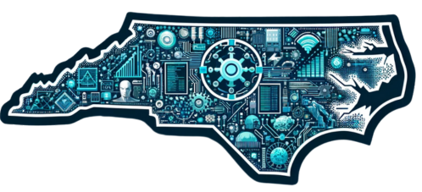

North Carolina
Generative AI Implementation
Recommendations and Considerations
for PK-13 Public Schools

Publication Date 1/16/24
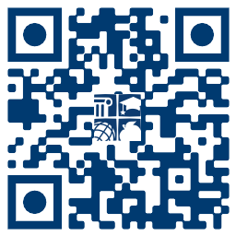

https://go.ncdpi.gov/AI_Guidelines

About this Resource

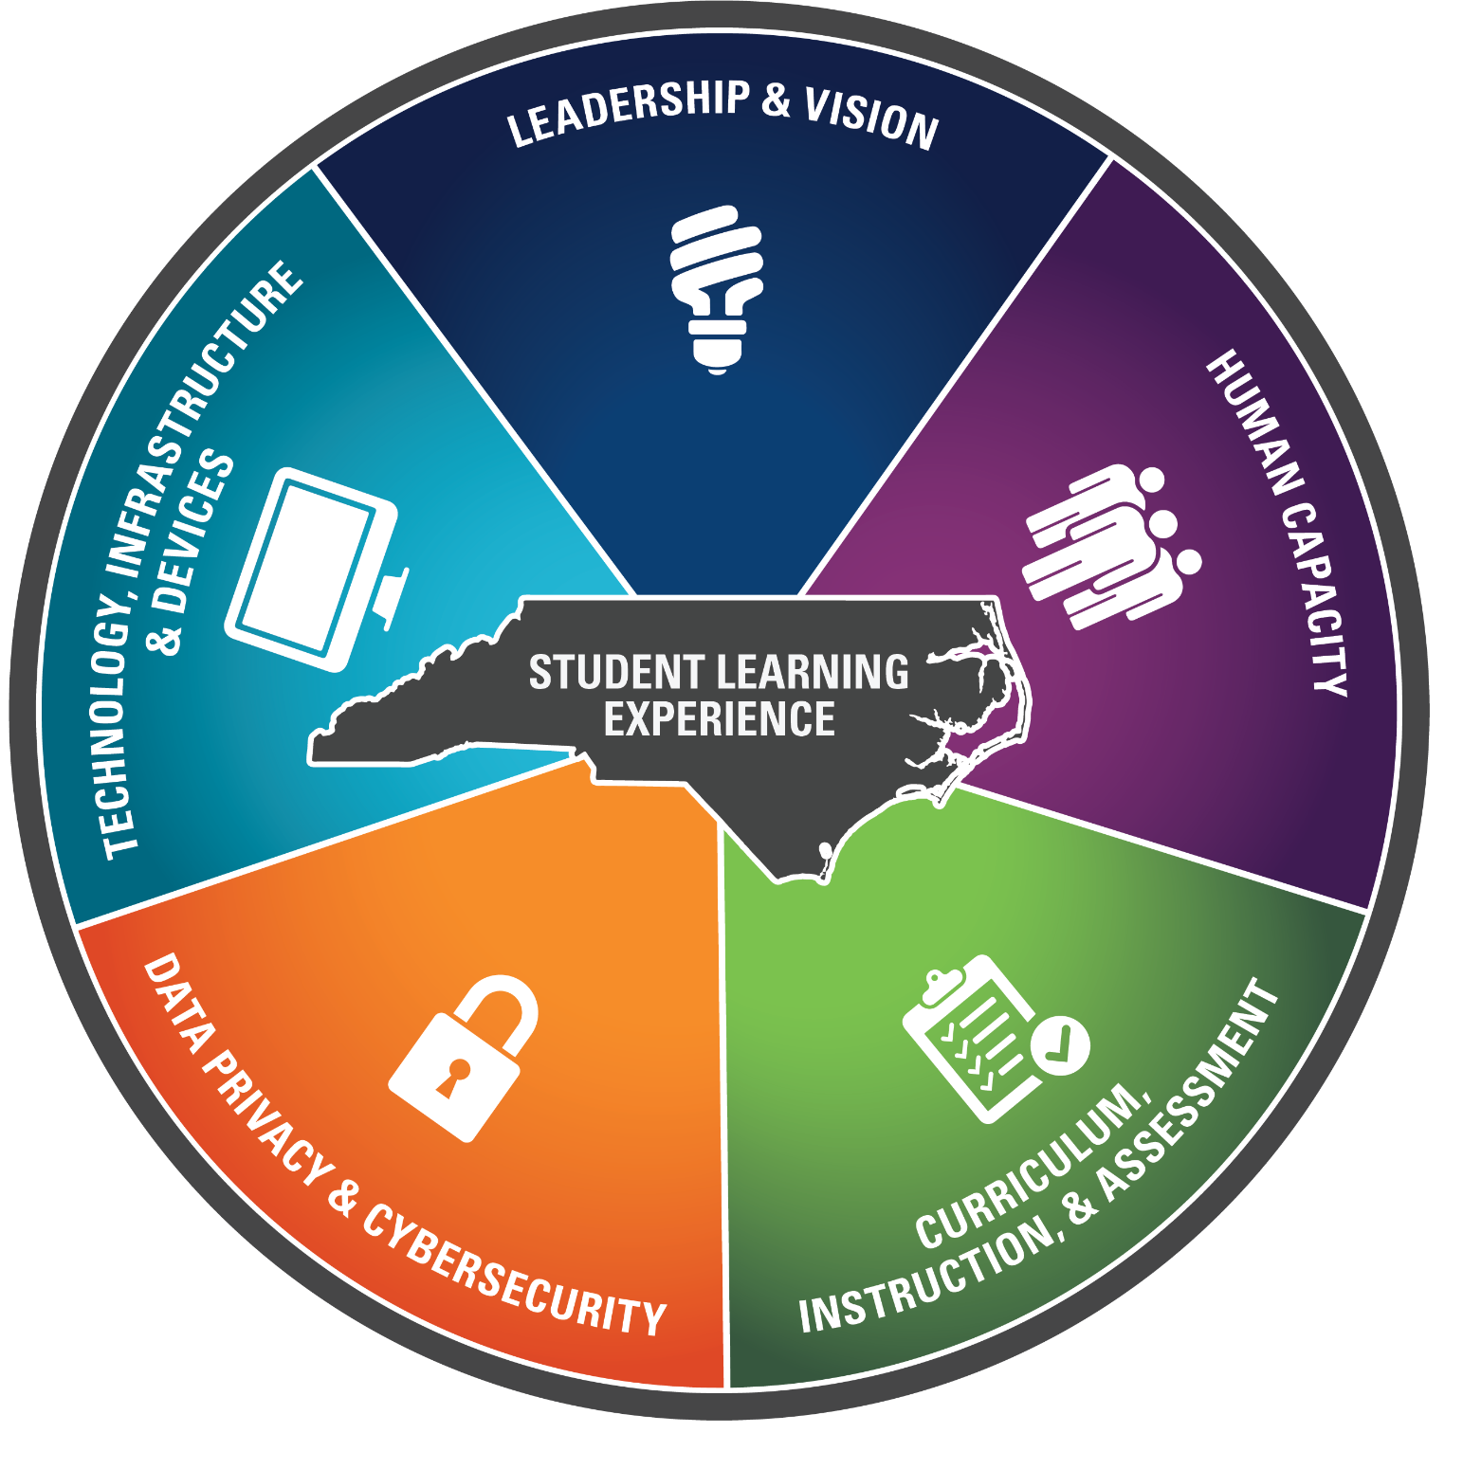
These generative AI implementation recommendations and considerations have been created as a way to share information and resources to direct the responsible implementation of generative AI tools and guide AI Literacy in North Carolina Public Schools.

These guidelines have been organized around the five focus areas of the North Carolina Digital Learning Plan, which guides digital teaching and learning for North Carolina public schools. The Digital Learning Plan encourages the safe use of innovative technology to prepare students for future school, improve student outcomes, and supports the appropriate use of technology to advance learning.

The Office of Digital Teaching and Learning, housed within the North Carolina Department of Public Instruction(NCDPI), supports educators in using generative AI safely to improve student learning. If you need assistance with implementing generative AI into your district or school, please reach out to your regional Digital Teaching and Learning Consultant. All regional DTL consultants’ contact information, as well as a wealth of other information, may be found on the DTL Hub webpage.

Acknowledgements:

This document was developed by the NCDPI AI Guidelines Committee, a collaboration between several different Offices within NCDPI and includes the following members:
- Vera Cubero. (Lead Contributor). Emerging Technologies Consultant; Office of Digital Teaching and Learning
- Dr. Ashley McBride(Contributor) Section Chief; Digital Learning Initiative
- Diane Dulaney(Contributor) Director, Office of Data, Reporting and Privacy
- Eli Hamrick IV(Contributor) Secondary Computer Science, IT, and Technology Education Consultant
- Timothy Wease(Contributor) PSU* IT Security Specialist, Cybersecurity Section
- Dr. Vanessa Wrenn(Contributor) Chief Information Officer; Technology Services and Digital Learning
- Josh Barton(Contributor- AI for Exceptional Children, Accessibility Advisor) IDEA Consultant for Assistive Technology; Office of Exceptional Children
Donna Murray(Reviewer). Digital Accessibility Specialist- IT Procurement, Accessibility, and Textbooks.

AI Use Disclosure
This update to the North Carolina Generative AI Implementation Recommendations and Considerations for PK-13 Public Schools was produced through a human-led process that incorporated selective assistance from OpenAI’s ChatGPT (model o3, ChatGPT Deep Research). ChatGPT was utilized as a partner with human oversight to generate outline options, provide feedback, suggest edits, convert source notes into MLA footnotes, and research recent AI-related research and policy references for the authors’ review.

Navigation
The document outline is available by clicking the ‘tabs and outlines’ icon in the upper left corner of this Google Document to show the tabs and outline. This outline serves as a clickable and navigable table of contents.

Version History
Because Generative AI is an emerging technology and is changing rapidly as are laws and rules governing its use, this is a living document and it will be updated as needed to reflect changes that take place in this very fluid environment. As updates occur that have significant implications in education, we will update this document.
The ‘Version History’ table below will include details of all updates and changes so that users can see at a glance what updates have been made.
Note that the last update will appear at the bottom of the title page for your reference.

Update Log:
Date | Version | Changes and Updates
1/16/2024 | 01 | Original publication
1/28/24 | 02 | - Minor technical edits/corrections  - Added Version History page p. 2  - Added example prompts p. 20  - Reorganized AI Literacy Recommendations by Grade Span and added new recommendations p. 17  - Added new resources to Appendix p. 33
2/18/2024 | 03 | - Technical corrections
3/4/2024 | 04 | - Added Student Facing AI Tools p. 19
3/5/24 | 05 | - Added AI Resistant, AI Assisted, AI Partnered Assignments p. 29
3/20/24 | 06 | - Updated Student-Facing Tools paragraph p.18;  - Removed Student Facing AI Tools graphic (was on p. 19) for updates
4/11/24 | 07 | - Added more guidance on Student Facing Tools p. 19 in light of new student-facing built-for-education models
4/28/24 | 08 | - Added resources- New Teach AI Policy, National Ed Tech Plan 2024  - Updated AI Assessment Scale to AI to ‘Student AI Integration: 0 to Infinity’ p. 25
8/5/24 | 09 | - Added links to editable Procurement/ Evaluation Tools p.11  - Clarified guidance around student-facing AI use by grade span p. 17  - Added link to 0 to Infinity GPT to p. 26  - Updates to AI for Accessibility based on recent developments p. 32  - Added guidance around deep fakes and cyberbullying p.33
11/15/24 | 10 | - Update: Gemini Teen now available 13 + p. 22  - Updated EVERY framework Graphic p. 27  - Additions to Accessibility: p.35  - New Resources Added to the Appendix  - AI Foundations for Educators Course added for educators Common Sense Media  - AI Parent Guide by Common Sense Media  - Avoiding Discriminatory Use of AI by US Dept. of Ed Office of Civil Rights
11/27/24 | 11 | Changed from PDF to Google Doc for improved accessibility.  Added long description links for all text-heavy images for screen reader compatibility  Replaced ‘Table of Contents’ with ‘Navigation’  Updated Job market statistics p. 4  Added Traditional to Transformational Learning p. 31
1/2/25 | 12 | Added 3 GPTs to support staff training on the included frameworks:  - CRAFT Prompt Wizard GPT p. 25  - Responsible Use EVERY Time GPT p. 28  - 0 to Infinity GPT p. 35
2/2/2025 | 13 | P. 11 Updated graphic to compare LLM models Jan. 30, 2025 https://go.ncdpi.gov/ComparingLLMs  P. 44 & 45 Added resources to Resources Section- Identified with 🎉 New
6/19/25 | 14 | ‼️New guidance about the growing concern of AI social companions (p 18)  Appendix- added new resources for K12 School Leaders and Staff Development
7/24/25 | 15 | Significant refresh based on recent developments:  - Moved ancillary materials to separate tabs as Appendix A-E  - Updated Introduction and Leadership & Vision Intro: P. 5-7  - Added details to the ‘AI Implementation Roadmap’ p. 10  - Added ‘Environmental Concerns’ & table with model selection tips P. 16  - Added ‘Google Gemini Update’ to P. 14  - Refresh of ‘Human Capacity’ section to align with new OECD AI Literacy Framework P. 20-25  - Updated AI Literacy Timeline P. 20-21  - Updated guidance on shifting pedagogical approaches in light of AI progress P. 22-24  - Updated guidance on prompting P. 25-26  - New Interactive student tool for the EVERY framework P. 26  - Updates to COPPA P. 32  - CRAFT framework v. 2.0 with Powerups Appendix C
7/28/25 | 16 | - Technical correction- updated links to images
8/28/25 | 17 | - Updates to the AI Literacy Timeline p. 24 and Appendix A to allow the indirect use of chatbots in PK-1 (teacher modeling, garnering student input etc). Direct use of chatbots is still not recommended at this level.
11/18/25 | 18 | New guidance about AI-Enabled Browsers (p. 6)
11/25/25 | 19 | Added statement about the importance of computer science education (p. 8)
12/1/25 | 20 | - Added Appendix D: Technical Assistance: Acceptable Use of AI for Special Education Teachers and Related Service Providers  - NEW Resources for ADMIN: AI Chatbots in Schools: A Practical Guide to Safety, Liability, and Mandated Reporting by Innovate EdDU Appendix E
1/29/26 | 21 | - Added introduction to the Human Agency & POG Durable Skills framework on P. 30  - Added Appendix F: Human Agency + NC POG Durable Skills (including example tasks)  - New resource for district leaders: SAIFCA (Safe Al for Children Alliance)- Updated Guidance on Schools Sharing Children’s Photos Online https://www.safeaiforchildren.org/guidance-on-sharing-childrens-photos/
2/2/26 | 22 | - Added the Human Agency & Judgment Gem (Appendix F)  🔗go.ncdpi.gov/Judgement-Agency-Architect-Gem  - Added guidance around autonomous agentic AI systems such as OpenClaw (p. 37)
2/13/26 | 23 | - New resource for parents- 🎉NEW Tips for Raising Resilient Learners in an AI World by the Brookings Institute in Appendix E: Parents/Guardians
2/25/26 | 24 | - New guidance on AI-Powered toys (p. 19)  - Excellent New Webinar and resources by AI for Education and Common Sense Media about AI Toys and Social Companions in Appendix F  - Added Appendix G resources “Micro PBL 2.0” informational guide with apps for educators to co-create standards-aligned Micro PBL 2.0 projects.
8/6/26 | 25 | Minor editorial corrections.

Introduction
Public education stands at the threshold of a new era defined by artificial intelligence (AI), demanding urgent action from educators and policymakers to prepare students for a future transformed by rapidly evolving AI technologies. A forward-looking approach is necessary because the landscape of AI has expanded dramatically and this exponential pace of innovation is expected to continue into the foreseeable future.
Since the public release of the North Carolina Generative AI Recommendations and Considerations for PK-13 Public Schools in January of 2024, we have witnessed exponential growth in generative AI capabilities including:
- Multimodal AI systems that can understand and generate realistic images, audio, and video that are virtually indistinguishable from reality
- Human-like AI systems that emulate human speech, intonation, and emotion
- Enhanced memory- AI tools such as ChatGPT now have the ability to remember all of a user’s interactions with the model
- Embedded AI assistants that are increasingly integrated into everyday software
- Agentic AI that can autonomously carry out tasks, use apps and tools, and interact with the internet and a computer in sequence with little human intervention
- Powerful reasoning models solve more complex problems with improved accuracy.
- AI-enabled physical AI: Advanced dexterity and reasoning in AI and robotics;AI-enabled robots, cars, & machines that can ‘see’ and reason to analyze and interact with their surroundings.
- New-AI-enabled browsers such as Perplexity Comet, Gemini in Chrome, ChatGPT Atlas, and CoPilot in Microsoft’s Edge browser all become widely available in October of 2025.

Emergent Security Risks
With these new capabilities come emergent risks, which will be added to the Data Privacy & Cybersecurity Section

AI and The Future of Work
The World Economic Future of Jobs Report for 2025 makes it clear that AI is set to be a major driver of both job creation and job displacement, necessitating significant workforce adaptation as well as significant changes in K12 education. A few of the findings of the report are:
- 170 million new jobs by 2030, a 14% increase over current numbers.
- Over 92 million jobs will be displaced, with a net employment increase of 78 million jobs.
- By 2030, 86% of employers expect AI to significantly transform their business.
- Employers expect that 39% of workers’ core skills will change by 2030
- AI, big data, and networks and cybersecurity are expected to be the top 3 fastest growing skills.
North Carolina’s surging tech, biotech, and advanced-manufacturing sectors echo a global reality: employers now prize the seven durable skills featured in the North Carolina Portrait of a Graduate as much as technical know-how. Those competencies: adaptability, collaboration, communication, critical thinking, empathy, a learner’s mindset, and personal responsibility retain their value no matter how the job market shifts, making them a must-have for every graduate. Equipping all students with AI literacy and durable skills, therefore, is a critical step to ensure they graduate ready for the high‑skill, high-demand jobs of the future. In order to equip students with these durable skills that are necessary for their future, instructional redesign is key. The Curriculum, Instruction, and Assessment section of this document details NCDPI recommendations for redesigning instruction for the Intelligence Age.
However, AI literacy is not just about career preparation; it is also increasingly vital for informed citizenship and lifelong learning. Today’s students will live the rest of their lives in a world where AI is an increasingly prominent part of daily lives, and in which it is increasingly difficult to discern whether the text, images, audio, and video they encounter online are human-generated or AI-generated deepfakes. AI-generated content can be used by bad actors to spread harmful misinformation, sway elections, perpetrate scams and frauds, and harm reputations. Being able to evaluate all media critically and making ethical decisions about the media one consumes, creates, or shares is an imperative for our students and for our democracy. Modern AI systems such as GPT-4, are “strikingly close to human-level performance” and can already pass tough exams, write convincingly human essays, and chat so fluently that many people find their output indistinguishable from a person’s. See appendix E for excellent resources on teaching students about deepfakes.
Artificial Intelligence (AI) has become a widely used tool in our everyday life, including for learning, personalised assistance, and entertainment. Therefore, young people must be able to understand how AI works, its societal impact, and how to use it ethically in order to be prepared for a society and economy in the age of AI.
AI Literacy Framework for Primary and Secondary Education
As also pointed out in the AI Literacy Framework for Primary and Secondary Education, "AI is not neutral; it is shaped by the decisions of those who build it." This underscores the importance of the human element in all choices made during design, data selection, labeling, and algorithm development and in teaching educators and students to critically evaluate all AI outputs.
By learning how AI systems work and what their limitations are, students will be better prepared to engage as thoughtful, ethical citizens in an AI-driven society. As a UNESCO report noted in 2024, “understanding the basics of AI is essential for everyone to thrive in this rapidly evolving landscape.” In short, AI literacy is now a cornerstone of civic literacy. It encompasses not only technical knowledge but also digital citizenship, internet safety, ethics, and an understanding of the societal impacts of AI.
It is also important to acknowledge that artificial intelligence does not exist apart from computer science. To ensure students understand AI equitably and responsibly, educational leaders are encouraged to provide broad access to computer science across K–12. When educators and students demystify AI systems, look past the “magic,” and build a conceptual understanding of how these tools work, they gain the skills needed to participate as ethical users and creators of emerging technologies. AI literacy is most effective when paired with computer science instruction, with computational thinking serving as the bridge between both areas. G.S. 115C-12(9d) requires the State Board of Education to include instruction in computer science in the Standard Course of Study for middle and high school students. It also requires every Public School Unit to offer an elective introductory computer science course in middle school and requires every high school student to complete at least one computer science course. The 2026–2027 school year is the full implementation year, and no PSUs will be eligible for a waiver.
In light of these facts, NCDPI encourages public school units to responsibly embrace AI and incorporate AI Literacy for all staff and students. The purpose of this document is to support education leaders and educators in all of our Public School Units in responsibly adopting AI technologies to better prepare North Carolina students for an everchanging world.

“The North Carolina Department of Public Instruction (NCDPI) advocates for the responsible integration of AI technologies in education, aiming to cultivate an educational environment that empowers each individual to reach their full potential and develop a lasting passion for continuous learning.”
Dr. Vanessa Wrenn, Chief Information Officer; NC Department of Public Instruction

Leadership and Vision

Leadership is not just about responding to change, it’s about shaping it. As generative AI accelerates the pace of transformation across every sector, education leaders in North Carolina are uniquely positioned to guide that change in ways that ensure equity, opportunity, and excellence for every learner. School boards, superintendents, district teams, principals, and policy leaders must work together to move beyond reactive policies and instead set bold, forward-thinking strategies for AI implementation. Our goal is not just to keep up with AI. It is to lead its responsible integration with purpose.

Closing the Digital Divide in an Age of AI
The TeachAI Toolkit reminded us that, “Attempts to enforce broad bans on AI are futile and only widen the digital divide between students with independent access and those dependent on school or community resources.” In the past, the digital divide centered on access to the internet and devices. Today, that divide includes AI access, AI literacy, and opportunities to learn with AI tools. If schools don’t provide equitable AI education, many students will be left behind, particularly those from low-income, rural, or historically marginalized communities who already face the most obstacles in attaining success.
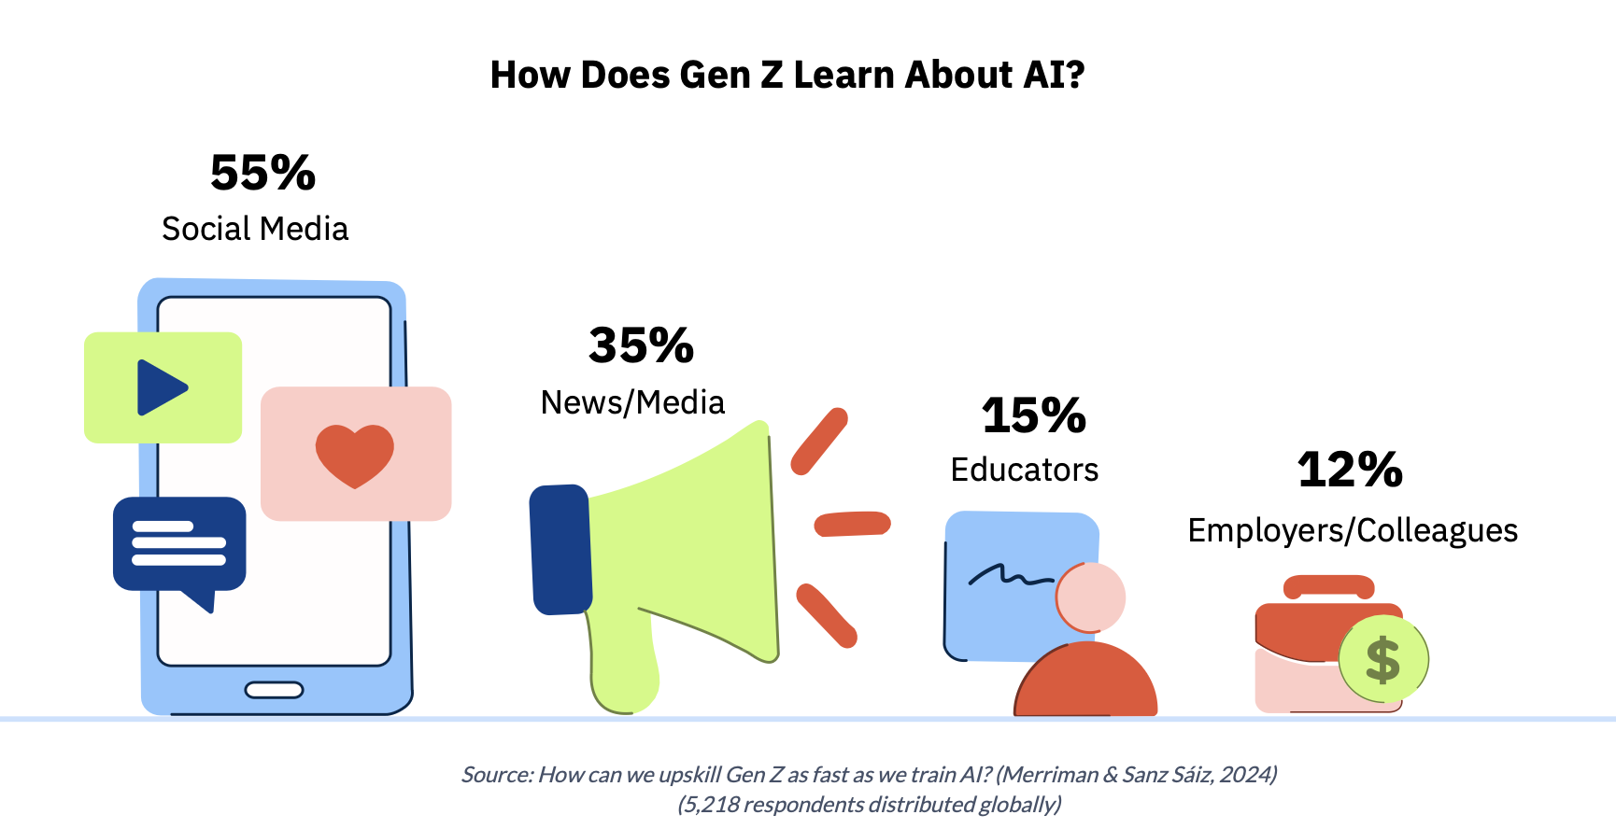
As this graphic from the AI Literacy Framework demonstrates, our students are already using AI and learning about AI in real time, scrolling TikTok hacks, testing Snapchat’s My AI, and watching YouTube explainer clips. Yet most of that exposure happens outside school walls, without structured guidance on accuracy, ethics, or responsible use. To close this critical gap, the AI Literacy Framework, published in 2025 by the European Commission and the Organisation for Economic Co-operation and Development (OECD), outlines the knowledge, skills, and attitudes students need to navigate, create with, and critically evaluate AI systems, and it places educators at the center of teaching safe, ethical, and effective practice. Integrating its principles will ensure North Carolina students learn about AI not just from social media, but from trained teachers who can scaffold critical thinking, equity, and responsible innovation across every grade and subject.
Our public schools must be the great equalizers. By offering all students and educators access to safe, age-appropriate, and ethically vetted AI tools and high quality instruction, we ensure that every learner, regardless of zip code, family income, disability, or any other factor is prepared for the world they will inherit. To do this, leadership teams must define a clear AI vision, build local policy, vet AI tools for privacy and compliance, and establish professional development pathways for educators. In doing so, schools will uphold their duty to both close opportunity gaps and foster future-ready learning environments that empower every student.

Portrait of a Graduate and the Leadership Imperative
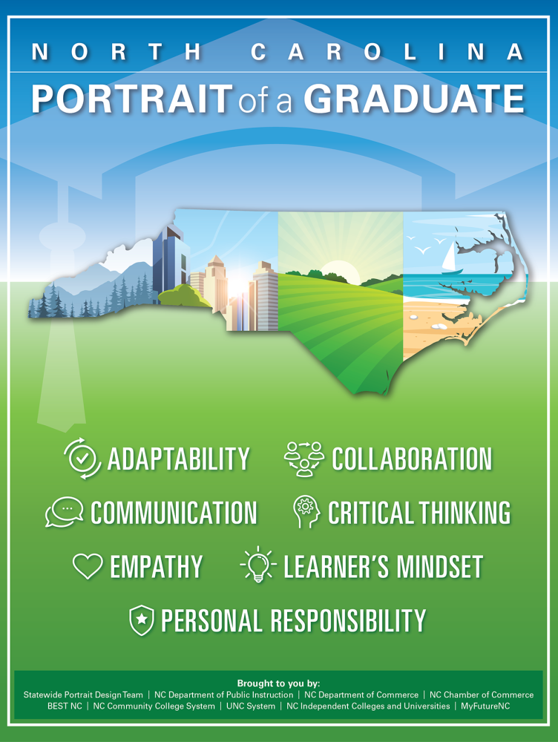
The seven durable skills outlined in North Carolina’s Portrait of a Graduate; adaptability, collaboration, communication, critical thinking, empathy, learner’s mindset, and personal responsibility are not only skills students need to thrive with AI. They are also the competencies that educational leaders must model in this moment of transformation. When leaders embody these skills, they model what it means to be future-ready, not just for students, but for staff and families. North Carolina's public school leaders are not just adapting to technology they are defining the role of education in the age of AI. It is through thoughtful, human-centered leadership that schools can remain places of creativity, connection, and equity even as our tools become increasingly powerful.

School and district leaders should also model these durable skills:

- Adaptability: Adjust policies as AI evolves.
- Collaboration: Build cross-functional teams for policy, training, and curriculum.
- Communication: Engage communities with clarity, transparency, and empathy.
- Critical Thinking: Evaluate AI tools rigorously.
- Empathy: Center AI policy, guidelines, and implementation with a human focus, inclusion, and accessibility.
- Learner’s Mindset: Stay curious and iterative as new models emerge.
- Personal Responsibility: Lead with integrity and foresight.

Appropriate Use of GenAI in Education

In 2023, the U.S. Department of Education popularized the metaphor of using AI tools in education as riding an electric bike, a partnership that multiplies the user’s effort while keeping the human in control. This metaphor remains powerful, but we have adapted it to reflect the student experience. The key takeaway is this: AI should not replace the rider, it should empower them.

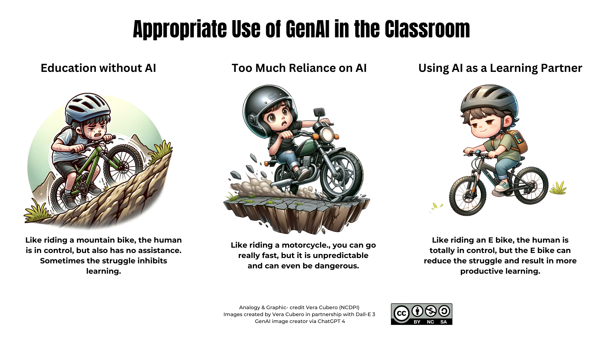

Access the image: https://go.ncdpi.gov/AI_in_Education-3Bikes

Today’s AI tools can be integrated into instruction with the right human guardrails to support student creativity, differentiation, inquiry, and agency. But as AI grows more agentic and lifelike, our leadership must ensure human values remain at the center of teaching and learning.

The Mindset Shift: From Restriction to Transformation
Many education leaders still feel pressure to restrict, block, or slow the use of AI in schools out of fear of cheating, bias, hallucinations, or ethical concerns. These concerns are legitimate, but they must not paralyze progress. Instead, leaders must embrace a balanced, strategic mindset that centers on three principles:
- Protect and Prepare
Ensure safety, privacy, and transparency while also preparing students for the real world
- Empower, Don’t Replace
Use AI to amplify human potential, not to bypass thinking or creativity.
- Lead with Vision and Purpose
Set a clear local vision for what AI-enhanced education looks like in your community.
Districts should establish AI implementation teams that include a wide range of education leaders, teachers, students, families, and community voices. Leadership means acknowledging the risks of AI, but not being defined by them.
The role of leadership in 2025 is not to answer every question about AI, but to create the conditions for ongoing inquiry, experimentation, and improvement. The rapid pace of AI evolution requires that school systems become more agile, reflective, and student-centered.

AI Implementation Roadmap for North Carolina’s Public Schools
NCDPI strongly recommends that each PSU follow this implementation roadmap, which includes creating a plan for building the human capacity/AI literacy of all staff and students and creating public-facing generative AI guidelines that ensure a common understanding of how generative AI tools may be used within the education system to further student learning.

The suggested roadmap for the responsible implementation of generative AI tools in North Carolina’s Public Schools was adapted from AI for Education’s ‘AI Roadmap for K12 Schools’.

- Establish a Foundation
  - Host an introductory meeting & training for district & school leaders, board, student leaders & other key decision makers
  - Create a cross functional team & develop detailed PSU-wide AI guidelines to guide the responsible implementation of AI into public schools. Include leaders, teachers, students, & community members
  - Review current EdTech providers deploying generative AI to vet their safety, privacy, reliability, and efficacy, to determine if they are appropriate to be used for your school, and which users they will be open to based on their Terms of Service and school or district policies
- Develop Your Staff:
  - Provide basic AI literacy training on what AI is and is not, how it works at a basic level, its benefits as well as its limitations and concerns, how to use it safely, ethically, and effectively and how to guide students in safe and ethical use.
- While this basic understanding is an important starting point, educators should continue to be supported and encouraged to use AI tools in their particular job contexts, provided opportunities to share and collaborate with other educators, and provided ongoing support as they adapt their instruction to the new realities of the AI age in which most traditional classroom and homework assignments can be created in seconds with AI and can not be detected.
- See the Appendix for vetted training resources.
- This professional learning must be differentiated, allowing educators at all levels from beginners to early adopters to engage meaningfully with AI based on their comfort, content area, and student population. Districts are encouraged to use microcredentialing pathways, coaching supports, and educator-led showcases to build internal expertise.
- Provide Ongoing Support
Encourage PLCs or sandbox periods where teachers can use AI tools for real tasks, lesson design, resource creation, accessibility support and reflect in PLCs or coaching cycles.
- Educate Students and the Community
  - Once educators have had professional development and time to develop their own skills and knowledge, begin educating the community about generative AI, PSU policies and guidelines, appropriate and safe use of generative AI, and the importance of AI literacy.
  - AI in the Classroom: Empower Students with Oversight. Allow students to use AI in age-appropriate ways (see AI Literacy Timeline below) that are aligned to state guidelines, PSU policy, PSU guidelines, and instructional goals. Ensure students have foundational AI literacy before use.
- Assess and Progress
Create plans and a cadence to review and update existing guidance as needed based on new developments and the experiences of your stakeholders.

PSU Generative AI Policy vs AI Guidelines

Balancing AI’s Beneﬁts with Ethical Considerations
Rather than creating strict restrictions, effective guidelines focus on empowering students and educators as well as ensuring ethical and responsible use.
- Academic Integrity: AI guidance should help educators adapt instruction and assessment to account for ubiquitous AI, while also teaching personal accountability and academic integrity.
- Ethical AI Use: Students should learn to critically analyze AI outputs and evaluate them for potential harmful biases.
- Data Privacy & Security: Schools must safeguard student information, address cybersecurity, and prioritize personal safety.
In a public K–12 school setting, AI policy outlines the rules and requirements; what must be done to ensure legal compliance, data privacy, and responsible use of generative AI. It includes enforceable directives aligned with state and federal laws (e.g., FERPA, COPPA), covering access controls, tool approvals, and disciplinary procedures. AI policy may be compared to the guardrails, setting firm boundaries to keep everyone safe.
In contrast, AI guidelines serve as a roadmap on what should be done to guide implementation and promote best practices. They provide a shared vision for how generative AI can be integrated into teaching and learning, ensuring that all staff and students become AI literate and can use AI safely, ethically, and effectively. Guidelines support professional development, curriculum alignment, and equitable access, empowering educators to rethink instruction with a focus on digital citizenship and future readiness.
AI Guidelines should be public-facing, apply to all stakeholders, and be flexible as AI is changing rapidly. They should help build a common understanding of appropriate AI use and common language among all stakeholders. As part of creating district-wide guidance, a comprehensive AI Literacy training plan should be developed to ensure that all users are trained specifically in the responsible, safe, and ethical use of generative AI. This is ultimately an exercise in AI project management & digital citizenship, selecting the right tools, setting guard-rails, and modelling civic-minded technology use for staff and students.

To support our PSUs in creating or updating their generative AI guidelines, the Office of Digital Teaching and Learning held in-person support workshops in the spring of 2025 for AI development teams and created a set of resources and templates (Google & Canva Formats). These resources and templates may be found in this shared Google Folder.

Developing Generative AI Guidelines at Your PSU
Adapted from AI for Education ‘Drafting a Generative AI Policy at Your School’

Guiding Questions
- How are students using generative AI? How are teachers using generative AI?
- What was the impact of the release of ChatGPT and other generative Al tools on your school?
- What are your biggest concerns about generative AI this year?
- What are the major ethical concerns your school has about GenAl?
- How can you adapt your current academic integrity policy to include GenAl?
- How can the use of generative AI tools help students with IEP, 504, language barriers, and other learning needs?

Key Steps
- Create a common understanding of Generative Al for all stakeholders through Al literacy.
- Design a clear set of guidelines that work for both students and teachers.
- Partner with stakeholders, including students, to develop and socialize the policy.
- Identify that the policy is a work in progress.
- Provide examples of the policy in stakeholder-specific language.

What to Include
- Appropriate Use of generative Al Tools
  - Identify what types of assignments and assessments can be Al-assisted with teacher approval and which must be completed without GenAl support
  - Provide examples of inappropriate use cases and appropriate use cases.
- Tracking and Citing generative Al
  - Provide guidelines on how students and teachers should track and cite their use of GenAl for their school work/practice
  - Provide examples of proper AI disclosure statements and citations in the correct format
- Data Privacy and Security
  - Clearly define what student, teacher, and school personally identifiable information (PII) includes.
  - Remind all users that PII is off-limits to generative Al tools (including uploading or pasting in of data into genAI models as well as typing it in a chat)
  - Provide a refresher for educators of student data privacy & FERPA
  - Add references to deep-fake images, audio, and video, including deep fake nudes or explicit content to students, faculty, or staff in the existing policies on cyber bullying/ bullying (see p. 35).

Strategies for Introducing the Guidelines to various Stakeholders…
Event | Primary Audience | Delivery Mode | Core Message & Activity
Kick-off Assembly | Faculty & district/school leaders | 15-minute rally during pre-service week | Launch vision for responsible GenAI; preview benefits and risks; share one success story; point staff to full guidelines.
Faculty or PLC Meetings | Teachers & support staff | 45-60 min workshop | Deep-dive into policy; explore case studies and debates in small groups; co-create classroom “dos & don’ts.”
Open House / Parent Meeting | Parents, guardians, community members | Interactive presentation with live demo | Explain why AI matters for students; outline safeguards; collect Q&A; hand out FAQ one-pager.
AI Literacy Week | Whole school (students & staff) | Themed week (posters, lunchtime demos, daily tips) | Build common language; showcase student-made debates or short videos on safe AI use.
Classroom Scenarios | Students (by class/grade) | Teacher-guided role-play & prompt analysis | Teach → Model → Discuss → Reinforce acceptable versus unacceptable AI use; students label examples.
Policy Exploration Workshops | Mixed stakeholder teams | Half-day design sprint | Map current integrity policy to the AI era; draft addendum; identify support needs.
Peer-Educator Campaign | Student leaders | Micro-lessons, posters, graphics in halls & LMS | Students champion common terminology; keep reminders visible all year.

Environmental Concerns
In addition to concerns regarding student well-being and ethics, all users of AI tools should understand the effects that AI technologies have on the environment and be thoughtful about their usage. While advancements are being made to reduce the environmental cost of developing AI models and newer models are increasingly more efficient when the end user engages with them, every AI prompt carries an environmental cost. Generally speaking, that cost increases with the complexity of the task and the longer it takes the model to provide an answer, the higher the environmental cost. Therefore, it is important for users to have a basic understanding of the various models, and what tasks each is best suited for. OpenAI’s next ChatGPT upgrade, GPT5 that launched in August 2025,introduced a hybrid, reasoning-based system that automatically selects the best model for each prompt yet still lets users override that choice streamlining workflows while encouraging mindful use of heavier models.
See the information below for quick guidance on which models to use for which purposes.

Quick Guidance on Model Selection:
 | Base (Non-reasoning) Models - Generally available on Free plans | Reasoning Models | Deep Research Models
Current models | ChatGPT 5.2  Gemini 3 Flash, Claude Opus 4.5 Haiku, Perplexity Sonar | ChatGPT 5.2 Thinking  Gemini 3 Flash Pro, 3 Pro Experimental  Claude Opus 4.5 | ChatGPT, Gemini, and Perplexity all call it ‘Deep Research’
When to use | For speedy checks, brainstorming, or auto-generating simple materials these models are cheapest and least energy-intensive. | when the task truly demands deliberate thinking, multi-modal analysis, or step-by-step logic, chain of thought reasoning | Reserve for big jobs like where automated sourcing and synthesis save hours but require much longer runtimes.
Example Use Cases | Grammar tweaks, flash-card lists, exit-ticket quizzes, lesson outlines, searches, etc | math proofs, cross-document feedback, code debugging,long-context image-text analysis | Literature reviews, policy briefs, annotated bibliographies, capstone projects
Example Prompt | Draft a 250-word summary of Chapter 3 of Hatchet at roughly Lexile 750L for a 5th grade student. End with one comprehension question and keep the tone upbeat. | Design a 3-day inquiry lesson on forces & motion for 7th-grade science (NGSS MS-PS2-2). Work step-by-step: 1) anchor phenomenon; 2) hands-on investigation; 3) formative checks; 4) student reflection. Anticipate two common misconceptions and explain how each activity addresses them. After thinking, present a polished lesson plan. | “Generate a policy brief (< 1,500 words) for district leaders on AI-powered reading interventions in K-8 (2020-present). Include: a 5-bullet executive summary; an annotated bibliography of ≥ 8 peer-reviewed studies; a comparison table of study design, sample size & effect size; gaps in current research; and MLA citations in-text plus a Works Cited.”
Why it fits the model | Single-shot content creation with no multi-step reasoning or external research needed. | Chains of thought, task decomposition, alignment to standards, hypothetical reasoning | Requires autonomous web search, multi-source synthesis, structured citations—work suited to deep-research agents.

Evaluating Generative AI Ed Tech Tools
Generative AI guidelines, policies, and Data Sharing Agreements should be carefully evaluated when making decisions about which tools to allow for staff and students. As with any digital tool, Public School Units should follow the terms of service, including appropriate age limits and seeking parental consent if required. It is recommended to consult with the technology director and, if needed, legal counsel, in evaluating the terms of service.

Most Large Language Models such as ChatGPT, Microsoft CoPilot, and Perplexity are currently prohibited for ages under 13 per their terms of service, but are allowed for ages 13 and over with varying parental/guardian permission requirements.

If your PSU decides to utilize a tool with students that requires parent/guardian permission, or if you decide to require parent/guardian permission for other tools, you may choose to customize this Example AI Permission Form. In some cases, it may be appropriate to include AI tool permissions in other technology policies. Regardless of whether an AI permission form is deemed necessary by the PSU, all staff and student users as well as all parent/guardians should be made aware of the school or PSU’s generative AI guidelines, including any academic integrity or acceptable use guidelines that reference the use and disclosure of generative AI and plagiarism. These guidelines should also be signed by both students and parents.

“Built-for-education” models:
Many school and district leaders continue to be understandably hesitant to allow tools such as ChatGPT for students even if they are 13 or older due to well-founded privacy and safety concerns. However, built-for-education models are becoming more readily available and may provide a safer (though not foolproof) way to allow older students to learn with AI. Currently, the only one of the large frontier model companies that provides an education version of their Large Language Model is Google’s, which now provides their Gemini 3 for all Google Workspace for Education users with enhanced data privacy including no training on chats. Google also allows for use for all ages with additional protections for under 18 users on Edu platforms (pending PSU policies and permissions). However, NCDPI continues to recommend against any interaction with generative AI chatbots for our PK-5 learners.
Several other built-for-education platforms (e.g., Khanmigo, SchoolAI, Magic School, Skillstruck Chat for Schools, Brisk etc) wrap frontier models- usually ChatGPT- in additional K-12 safeguards, but still require PSU vetting and AI-literacy training. As discussed in the previous section, the capabilities of AI models have drastically accelerated while costs have declined, resulting in more ubiquitous access to very powerful AI tools that will likely increase into the future.

Social AI Companions & AI Toys: Growing Concerns
A new genre of “social AI companions” is moving from text-only chat to fully multimodal interactions and have changed the way people use AI. Character AI, for instance, is rolling out character bots that converse through video and voice, blurring the line between simulated friendship and real-world relationships. Common Sense Media has rated social AI companions as an ‘unacceptable risk’ for anyone under 18 for the reasons below and NCDPI agrees with this assessment. These tools raise significant red flags that school leaders must understand and address.
The latest data from Harvard Business Review for 2025 showed the largest increase in personal and professional support, with ‘therapy/companionship’ rising to the most common use case, ‘organizing my life’ and ‘finding purpose’ as the second and third most common use. A recent study by Common Sense Media found that 72% of teens have used AI companions, with 52% using them multiple times a month. As AI evolves to meet deeply human needs, schools must evolve too, preparing students not only to use AI tools, but to navigate complex ethical, emotional, and societal implications.
NCDPI strongly discourages the use of AI tools such as CharacterAI and other role building/role playing AI platforms for anyone under the age of 18, especially for therapy or companionship. Still, we must face the reality that many of our students are using it this way or will use it this way in the future. Education institutions should ensure that today’s students have a solid foundation in AI Literacy to guide them to making safe, ethical, and responsible decisions as they will live their entire lives in an increasingly AI-enabled world.

Mitigating the risk: Because the risks of AI companions outweigh any instructional benefit, social AI companion apps should be blocked on PSU-managed devices and networks, and educators should incorporate digital-citizenship lessons that help inform students, parents, and guardians of these risks.

AI-Powered Toys
AI-powered toys are an emerging concern. Their outputs can be unpredictable and hard for adults to supervise in real time, creating risk of unsafe or inappropriate conversations and persuasive dynamics that children may not recognize. This category now includes major-market signals, such as Mattel’s announced collaboration with OpenAI to develop AI-powered products and experiences, alongside already-available WiFi-connected and always-listening “conversation” toys like Curio’s Grem.
These toys may also undermine children’s social development by reinforcing sycophantic, always-agreeable interaction patterns rather than practicing real-world skills like disagreement, and perspective-taking. AI-powered toys also raise data privacy risks as children’s voice interactions may be transmitted, stored, or shared, increasing the possibility of exposure or breach.
For these reasons, NCDPI strongly recommends against the use of AI toys by children at this time. Current AI technology is simply too new, too misunderstood, and too unpredictable to trust in the hands of children. However, the growing availability of AI-enabled toys and proliferation of AI social companions is further evidence of the urgent need for AI literacy in schools so students can identify system limitations, privacy risks, and manipulation patterns and make safer choices.
See Appendix E: Parents for timely and important resources about AI Social Companions and AI Toys.

Key Concerns of Social Companions and Toys for PK-13 Students:

- Emotional manipulation & dependency- Companion bots are engineered to foster intimacy, encouraging students to confide deeply and potentially displacing healthy peer or adult bonds.

- Sexual content risk- Independent reviews show many popular apps can be prompted to shift into explicit role-play, sometimes involving minors, after only a few prompts.

- Mental-health harms- Chatbots are prone to sycophancy, tending to agree with and attempt to please the user rather than provide correction. This behavior can contribute to a user’s misaligned and even dangerous intent and stunt the development of dealing with disagreement or conflict; an important social skill. In some instances, chatbots have provided content that encourages self-harm, disordered eating, or running away, highlighting the danger of unmoderated, always-on “support.”

- Unqualified counseling- Students may treat bots as therapists; advice is not evidence-based and can reinforce harmful behaviors or spread medical misinformation.

- Data Privacy & compliance gaps- Most apps lack robust age verification, creating FERPA/COPPA vulnerabilities when used on school networks or devices.

- Addictive design & screen-time- Instant emotional feedback keeps students engaged for hours, undermining focus, sleep, and in-person socialization.

- Personal information disclosure- Students may build trust with AI Companion and disclose PII

Human Capacity

AI is already ubiquitous in all aspects of our daily digital lives.
One can’t go online or on social media without encountering AI-generated content, even if it is not always recognized as AI-generated. Our students’ levels of AI literacy will have profound impacts on work, education, the economy and all aspects of their lives in an AI-enhanced world in which humans interact with AI increasingly more each day and in which the old mantra ‘seeing is believing’ no longer holds true.

Generative AI is changing not just the tools we use, but the very nature of how we teach and learn. As AI grows more ubiquitous and more capable, human capacity becomes even more essential. Building human capacity means equipping all educators, staff, and students with the skills, mindsets, and confidence to use AI responsibly, creatively, and effectively. Educators will need to take on the roles of ethical guides, critical evaluators, and learning designers.
This urgent need for widespread AI literacy has been recognized at the highest levels of the US government. President Trump signed an executive order on April 23, 2025, titled "Advancing Artificial Intelligence Education for American Youth". This order establishes artificial intelligence education as a national priority for K-12 schools and aims to promote AI literacy and proficiency among American youth to prepare them for the future workforce. Key components include the creation of a White House Task Force on AI Education, a Presidential AI Challenge, the development of K-12 AI education resources through public-private partnerships, enhanced teacher training on AI, and the expansion of AI-related apprenticeship programs. While this is a new development, NCDPI will monitor it closely and update this guidance as needed.

AI Literacy Is an Imperative
Failing to train educators and students in AI leaves the most vulnerable behind, widens existing inequities, and reduces future opportunities. In addition to creating policy and guidelines to steer the responsible implementation of generative AI, PSUs must also develop an effective plan to ensure that all students and staff develop AI literacy. NCDPI has adopted the AI literacy definition in the newly released AI Literacy Framework by TeachAI and other global partners.

AI literacy represents the technical knowledge, durable skills, and future-ready attitudes required to thrive in a world influenced by AI. It enables learners to engage, create with, manage, and design AI, while critically evaluating its benefits, risks, and ethical implications. (AILit Framework, 2025)

The AI Literacy Framework includes Four Domains of AI Literacy: Engaging with AI, Creating with AI, Managing AI, and Designing with AI to help clarify different ways that humans may interact with AI tools.
The AI Literacy Framework interweaves Knowledge, Skills, and Attitudes throughout these four domains and twenty two competencies to provide a durable foundation for AI literacy. These knowledge, skills, and attitudes should underpin ethical and responsible AI implementation and AI literacy in K12 education:
- Knowledge – grasp how AI processes data, differs from human thinking, and potential concerns such as AI’s potential to inherit or amplify bias
- Skills – apply critical thinking, creativity, and computational thinking to use AI effectively and ethically, shaping its role in daily life
- Attitudes – cultivate curiosity, adaptability, a habit of questioning AI outputs, and a commitment to responsible use

Educators must also have an understanding of how AI is evolving.
The generative AI of 2023 tools like ChatGPT that could summarize text and write emails is quickly being eclipsed by new reasoning models (like Claude Opus 4.5 and GPTo3), which analyze, plan, and multi-step reason across tasks. These models go beyond prediction; they simulate chains of logic and perform deeper analysis, allowing students and educators to explore more complex ideas together. In addition, multimodal AI models now process images, text, audio, video, and code in a single interaction and even utilize those multimodal files that are added to the chat to help reason and produce an output. This opens doors to more accessible, creative, and inclusive learning.
Emerging agentic AI systems that are capable of autonomous task execution and computer use are entering experimental use in productivity and education. Educators must be prepared not only to understand these tools, but also to teach, guide, and model their use ethically, especially as models begin exhibiting increasingly human-like outputs, including emotional mimicry in voice and character interactions.
Invest in AI Literacy Training for ALL staff and students FIRST before investing in tools.

Prioritizing AI literacy equips educators and students with the critical thinking, ethics, and adaptability needed to evaluate any future technology. When a solid understanding comes first, rapidly evolving tools become opportunities not obstacles to responsible, creative learning.
To ensure responsible, safe, and ethical implementation of generative AI, staff and students who are of the age to use generative AI should be trained on safe, effective and responsible use including the following key aspects, each of which is covered in more detail in the ‘Curriculum and Assessment’ section of this document.

- Alignment with PSU and school-based guidelines/policies governing generative AI usage.
- Building a basic understanding of generative AI: how it works, a balanced view of its power to transform learning and the concerns and limitations of current models.
- How AI impacts education, including potential future implications on the job market.
- Effective communication with the Large Language models (prompting).
- Safe, Ethical Use and Disclosure of Use and PSU and school guidelines.
- AI as a Learning Partner to support curriculum standards, enhance human creativity & critical thinking.

Professional Development for the Age of AI

In this new landscape, educator professional learning must be ongoing, immersive, and job-embedded in the day-to-day work of all educators. The rapid pace of AI development demands an agile workforce, constantly updating its own understanding, adapting pedagogy, and modeling safe, ethical practices.North Carolina strongly recommends a four-stage AI human capacity-building plan based on the AI for Education “AI Adoption Roadmap for Schools and Districts”

North Carolina’s four-stage plan builds AI capacity by first equipping educators with foundational literacy, then sustaining their growth through ongoing support, and finally extending responsible, age-appropriate AI use to students and the wider community

Modeling the Portrait of a Graduate
Just as students are expected to develop North Carolina’s seven durable skills, educators must also model these competencies as they adapt to AI-rich environments:
- Adaptability: Navigating changing tools and workflows
- Collaboration: Sharing strategies and co-creating policy
- Communication: Explaining AI’s role clearly to families and students
- Critical Thinking: Vetting tools, verifying AI outputs, identifying bias
- Empathy: Considering equity, accessibility, and learner voice
- Learner’s Mindset: Embracing new technologies with curiosity
- Personal Responsibility: Ensuring ethical, safe, and transparent use
As leaders in learning, educators must embody these traits to guide students through the exponential shifts in all areas of our lives resulting from AI advancements.

Laying the Foundation for Student AI Use
Before students engage directly with AI tools, educators leading their use must be AI literate and prepared to teach and support its responsible use. PSUs should provide time and support for teachers to build their own AI literacy through professional development and job-embedded AI use as well as time to review tools, ask questions, express concerns, and give feedback before student implementation. AI Literacy will require an increased emphasis on media literacy, critical evaluation of bias / hallucination, and ethics. No student regardless of age should interact with AI in a school setting without adult guidance, aligned policies, and foundational understanding (basic AI literacy), or outside of PSU AI guidelines.

All students can and should learn ABOUT AI in age-appropriate ways before they are ready to learn WITH AI.

This approach affirms that AI literacy is not optional; it is central to the responsible integration of generative AI. Technology alone cannot transform education; it is only through human intelligence, reflection, and ethical use that these tools can be used to enhance equity, engagement, and opportunity. We have provided a list of high-quality, free professional development for education leaders, teachers and students in the appendix of this document. Please see the Appendix F for these recommendations.

To ensure responsible, safe, and ethical implementation of generative AI, staff and students who are of the age to use generative AI should be trained on safe, effective and responsible use including the following key aspects, each of which is covered in more detail in the other sections of this document.

- Alignment with PSU and school-based guidelines/policies governing generative AI usage.
- Building a basic understanding of generative AI: how it works, a balanced view of its power to transform learning and the concerns and limitations of current models.
- How AI impacts education, including potential future implications on the job market.
- Effective communicating with the Large Language models (prompting).
- Safe, Ethical Use and Disclosure of Use and PSU and school guidelines.
- AI as a Learning Partner to support curriculum standards, enhance human creativity & critical thinking.

From AI Awareness to AI Fluency: NCDPI AI Literacy Timeline PK–13 and Educators: v. 2.0
Please refer to the full NC AI Timeline Guidance in Timeline Guidance in Appendix A: AI Literacy Timeline v. 2.0

The updated AI Literacy Timeline incorporates the ‘Knowledge Skills and Attitudes’ as well as the four domains from the AI Literacy Framework to better clarify how students should be engaging with AI systems based on grade span. This timeline supports North Carolina educators in scaffolding AI instruction responsibly, ensuring safe, age-appropriate use that aligns with state goals for digital citizenship, personalized learning, and future-ready graduates.
The goal is to ensure age-appropriate, safe, and meaningful integration of AI starting with simple awareness in early years, beginning AI literacy in upper elementary, building on that understanding in middle school, and achieving AI fluency in high school and beyond. Below is a breakdown of each bucket and grade band, with descriptions and practical examples for implementation.
NCDPI recommended progression of AI-related skills in education can be structured into three developmental buckets: AI Awareness, AI Literacy, and AI Fluency.

AI Awareness: Learn ABOUT AI with focus on literacy (Grades PK–5)
- PK– students begin by learning about AI through literacy-rich, teacher-led activities without any chatbot use or exposure. The focus is on developing the literacy, curiosity, and critical thinking skills needed to understand how AI exists in the world around them.
- Grades 6–8 students begin developing deeper AI literacy by actively learning how generative AI systems work, identifying limitations and biases, and interacting with AI tools in structured, supervised settings. The focus shifts to responsible prompting, ethical use, fact-checking, and critical evaluation of AI-generated content.
- By high school (grades 9–13+), students move toward working alongside AI, using it as a collaborative partner to solve problems, generate ideas, and engage in responsible co-creation. At this level, students should be fluent in ethical use, transparency, and academic integrity, and they should be able to critically oversee and revise AI-generated content.

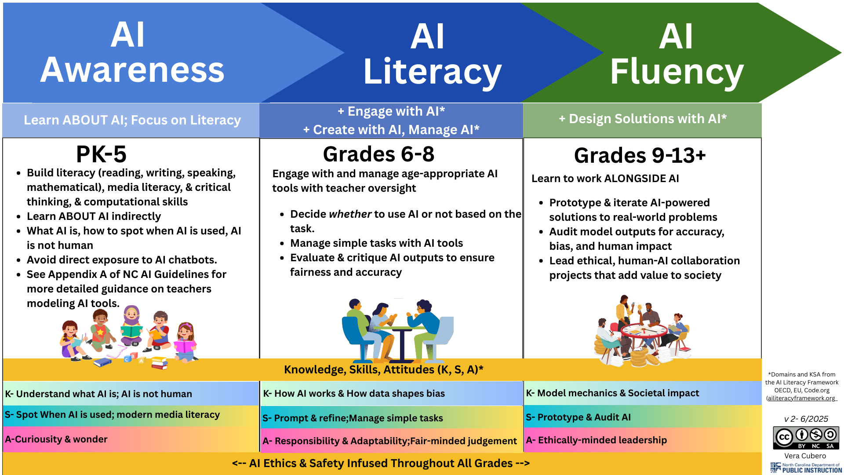

- Download this image for printing: go.ncdpi.gov/NC-AI-Lit-Timeline-v2
- Please refer to the full NC AI Timeline Guidance in Appendix A: AI Literacy Timeline v. 2.0

Curriculum, Instruction, and Assessment

To ensure our students are prepared for the emerging Intelligence Age, North Carolina's approach to curriculum, instruction, and assessment must fundamentally evolve to leave behind the rigid industrial-era models and embrace educational frameworks that prioritize critical thinking, ethical technology use, collaborative problem-solving, and adaptive expertise, empowering our students to not just survive but thrive as creators, innovators, and mindful digital citizens in an AI-transformed world. Generative AI is not just another tool. Generative AI represents a paradigm shift in how we teach and learn, disrupting a schooling model that has remained largely unchanged for over a century and still in many ways resembles industrial models that over emphasize memorization and outdated skills rather than transferable and future ready skills such as the seven durable skills of the NC Portrait of a Graduate. To harness AI’s potential while preserving what makes education human, we need to shift from product-oriented instruction toward increased student agency, creativity, real-world problem-solving, and a focus on the process of learning rather than just the end products. This means redesigning learning experiences so they are authentic, student-driven, and process-focused, with AI serving as a collaborative partner in learning rather than a simple shortcut or threat.

Embrace Authentic, Student-Driven Learning:
The rise of AI can be a catalyst for shifting education toward more student-centered pedagogies that will better prepare students for an uncertain, but certainly AI-rich future. If routine tasks and basic content generation can now be offloaded to AI, teachers and students can spend more time on deeper learning experiences which provides an opportunity to transform classroom practice. However, keeping education relevant in the Intelligence Age will require adapting pedagogical approaches and transitioning from the traditional teacher-centered classrooms that served our students well in the past to the student-centered, active learning classrooms that will serve our students well in the future. Focusing on these four pedagogical shifts to move from traditional to transformational learning in the age of artificial intelligence.
North Carolina’s Strategic Plan 2025-2030 recognizes the need for safe, responsible, ethical use of AI and collaborative problem-solving as integral to the modern educational experience.
Establish scalable approaches to embed artificial intelligence safely, responsibly and ethically, and ensure collaborative problem-solving is included in the learning experience.
“Achieving Academic Excellence” North Carolina Strategic Plan [Pillar 1.F4.A5]
See Appendix G: Micro PBL 2.0 for an informational explanation of PBL 2.0 as well as access to two apps teachers can use to co-create standards-aligned Micro PBL 2.0.

Redefining the Teacher’s Role and Human Skills Development:
With more freedom to innovate, teachers can more easily act as coaches and facilitators, guiding students through project work, Socratic discussions, and design challenges. Classrooms can transform into laboratories of exploration, where collaboration, creativity, and critical thinking are at the forefront. When used skillfully, large language models and other AI tools can dramatically reduce the time teachers spend on administrative and preparatory tasks (e.g. drafting lesson plans, grading drafts, writing routine emails), freeing up more time for direct student interaction and individualized support. In short, AI can hand educators back the time and flexibility to focus on why they became teachers in the first place; guiding and inspiring young people.

Ultimately, the goal is to blend AI literacy with human literacy: students must learn how to learn and adapt in an AI-rich world, becoming fluent with the technology but grounded in uniquely human strengths.

The rise of AI makes these transferable human skills more important, not less. While AI excels at processing information and automating routines, it lacks the nuanced judgment, ethics, and empathy that students must develop for the future. Instruction should, therefore, explicitly cultivate skills like problem-solving, ethical reasoning, teamwork, and adaptability. For example, class activities might involve ethical debates on AI outputs, group problem-solving tasks, and reflection journals, all of which build the human capacities that complement AI capabilities. By leveraging AI as a teaching assistant, educators can put even greater emphasis on these higher-order skills.

Large Language Models (LLMs) – A New Kind of General Purpose Technology
At the heart of this transformation are advanced AI systems like large language models. An LLM (such as OpenAI’s ChatGPT) is a generative AI program designed to produce human-like text based on patterns it learned from vast amounts of data. Educators and students do not need an in-depth technical background on machine learning, but they should grasp that these AI tools work differently from Google searches or textbooks. A basic understanding of how AI models function and their limitations is now considered part of digital literacy. (For a practical primer on LLMs, see the AI Literacy Foundations for Educators training modules in Appendix E). By building a baseline AI literacy among staff and students, schools ensure that everyone knows how to use these tools responsibly and effectively, verifying AI-generated content, protecting data privacy, and recognizing biases, before integrating them deeply into learning.

Updated Guidance on Effective Prompting
One of the most important new skills for both teachers and learners is mastering the art of prompting AI to get useful results. Creating effective prompts is like knowing how to ask good questions, a critical component of inquiry-based learning. Simple one-line prompts (e.g. “Explain photosynthesis”) may yield basic answers, but deeper learning comes from engaging in a dialogue with AI and giving it explicit instructions and rich context.
Modern reasoning-rich models (ChatGPT 5.1, Gemini 3, Claude Opus 4.5) can process less structured, more conversational prompts than earlier models, but a clear prompting framework is still valuable whenever you need consistency, accountability, or to teach novices to ensure effective use and positive early impressions.
Why Prompting Matters:
- Builds future‑proof skills: Learning to communicate effectively with AI models is an important skill now and in the future.
- Boosts AI quality: Clear context, precise roles, examples, reference files, and explicit output formats reduce hallucinations and make responses instantly usable
- Models good thinking: Prompting is communicating! Practice with prompting trains students to communicate effectively and builds problem‑solving.
- Harnesses new capabilities: Multimodal inputs leverage cutting‑edge features that make learning more interactive and accessible.
Ultimately, learning to communicate your needs to an AI and to critically evaluate the AI’s output is now a core competency. It’s a skill best learned by doing, so teachers and students should be encouraged to experiment with prompts and share what works. See Appendix C for information on the updated CRAFT Prompting Framework.
Prompting strategies will likely evolve as new capabilities emerge, but the most important skill to maximize the value of generative AI is to communicate effectively; provide clear, specific instructions with adequate context, and verify all AI-generated outputs.

Clarity > Courtesy
While LLMs excel at generating content and analyzing information, they function best as collaborative partners rather than autonomous decision-makers.
When ChatGPT and other LLMs first became mainstream, a lot of people recommended being polite to the chatbot, such as saying ‘please’ and ‘thank you’. However a wave of 2025 evidence refines how users should frame politeness with AI models. Prompt-engineering tests show that courtesy does not improve output quality compared with plain, well-structured instructions, underscoring that clarity outranks manners in effective prompting. Sam Altman’s comment that extra “please/thank-you” tokens cost OpenAI “tens of millions” in electricity also highlights a teachable link between concise language and stewardship of the environment.
Researchers also found that polite requests can make large models more willing to generate misinformation, offering a great opportunity to enhance critical thinking for students by having them analyze how tone nudges bias and refusal rates. You will get better results if you focus on being clear, concise, and direct when interacting with LLMs and other AI systems.
As the lines between AI and human content continue to blur, educators should be particularly mindful of avoiding anthropomorphizing language (assigning names, pronouns, emotions to the models) when modeling or discussing AI use with students. While LLMs engage in increasingly human-sounding ways, and can emulate human emotions and empathy, it is important to remember that they are not human, to emphasize this to students of all ages, and to model appropriate interactions with humans as well as AI systems. To help students draw clear distinctions between interacting with humans and interacting with AI systems, educators should teach and model the appropriate way to act with humans in contrast with appropriate and effective communication with AI systems.
The following statement sums up this contrast:
Save your manners for humans! Always be kind and polite when communicating with humans, but focus on being clear, concise, and direct when interacting with LLMs and other AI systems.

Human Judgment & Agency + NC Portrait of a Graduate Durable Skills
As we navigate this Intelligence Age, the question is no longer *if* our students will use these tools, but *how* they will lead within a landscape where technical proficiencies shift daily and the "irreplaceable core" of human judgment becomes the primary currency of the future.
To truly prepare learners, we must look beyond mere tool adoption and center our instruction on durable skills such as the seven durable skills that are the anchors of our NC Portrait of a Graduate: adaptability, collaboration, critical thinking, empathy, learner’s mindset, and personal responsibility; ensuring that while AI may generate options, our students possess the agency, ethics, and wisdom to own the decisions. We have created a framework that combines the need for human agency with the seven durable skills of the North Carolina Portrait of a Graduate.

The Core Principle
Instructional redesign protects the Irreplaceable Core:
- Thinking
- Judgment
- Ethical decision making
- Personal Responsibility
"AI should increase cognitive demand, not reduce it.”

The Teacher's Role
Non-Negotiables
- Teachers do NOT need to become AI experts or abandon standards.
- Teachers DO need to require justification, defense, and student leadership.
Three Critical Questions
- Where does judgment live?
- What decision must students make?
- How will I see their thinking?

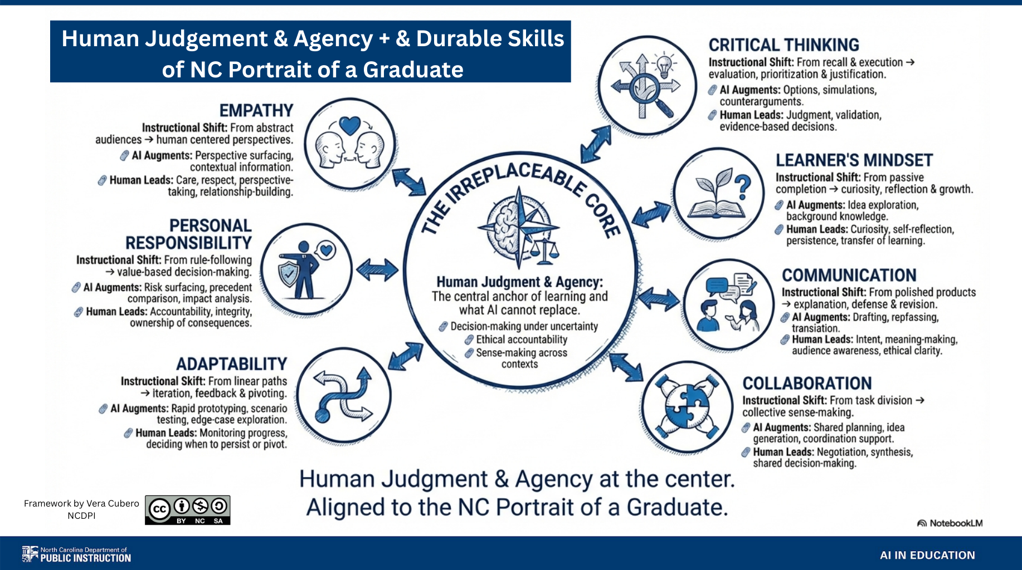

You may review the framework along with example student tasks in Appendix F.

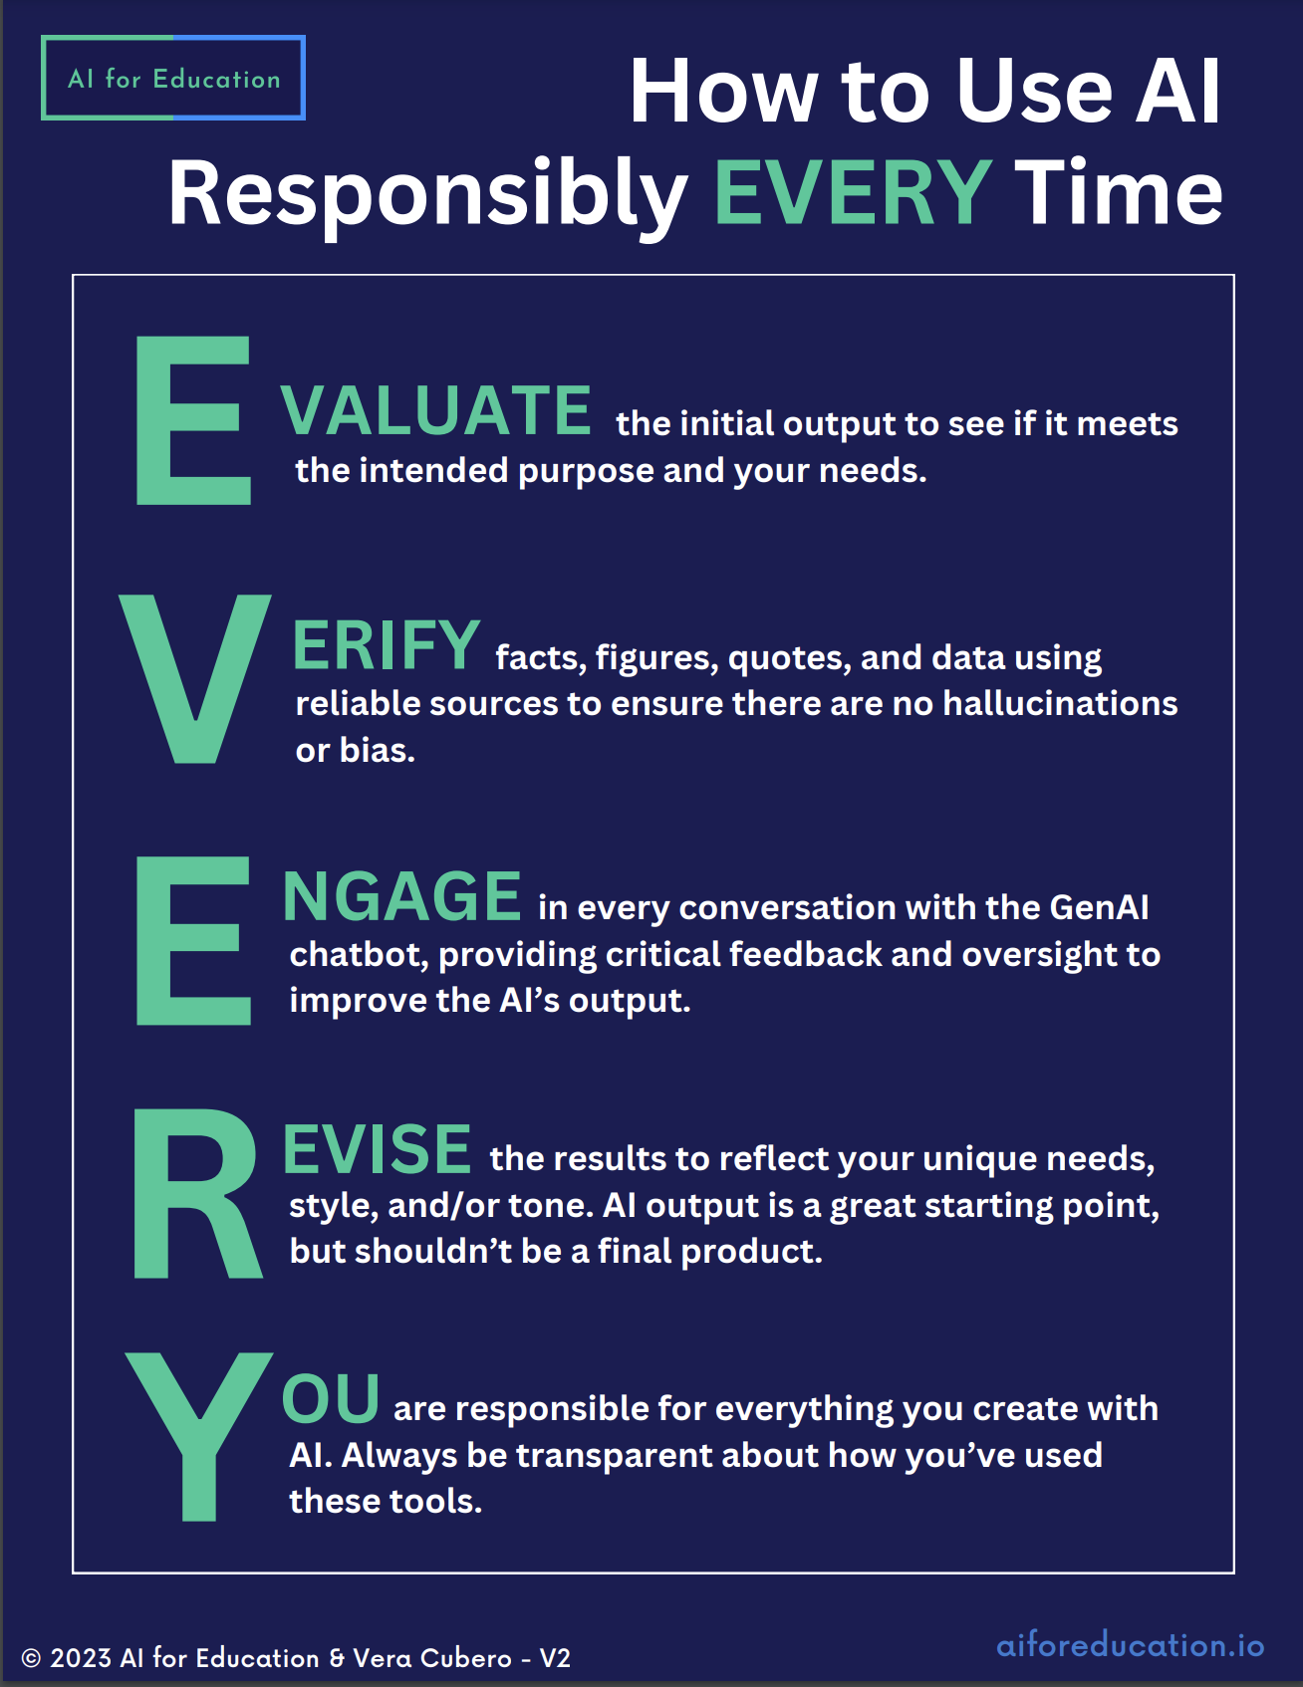
How to Use AI Responsibly EVERY Time
The EVERY framework, created by AI for Education and Vera Cubero (NCDPI), distills responsible AI practice into five easy steps: Evaluate, Verify, Engage, Revise, and remember that You are responsible for the final product. Use this checklist train and reinforce responsible AI use with students as they interact with a generative AI tool to keep outputs accurate, ethical, and authentically yours.

Try it Out!
- EVERY Interactive Teaching Tool by Vera Cubero to understand the steps of the EVERY framework (accessible to all students and educators) https://go.ncdpi.gov/EVERY-Interactive
- Responsible Use EVERY Time GPT by Vera Cubero(accessible to educators and students who are allowed to access ChatGPT store). Reinforce the steps of the EVERY framework. https://go.ncdpi.gov/EVERY-GPT

Disclosing AI Use or Citing Generative AI as a Source
Educators should lead by example and model mandatory AI-use disclosure statements and academic honesty about their use of generative AI tools, and teach students to do the same. Because today’s generative AI tools can not actually create content without some level of human participation and guidance, it is generally considered best practice to acknowledge the use or partnership with the AI tool when a formal citation is not required.
In a recent publication, the US Copyright Office determined that purely AI-generated material is not copyrightable, and trademark or copyright applications must list a human or legal entity who exercised meaningful creative control. Outputs that mix AI assistance with original human expression can be protected, but only the human-created portions qualify. Because generative AI is still somewhat new, there will likely be further litigation surrounding AI and copyright.

If traditional citations are not required, but any form of AI assistance was used, it is recommended to include:
- the name of the person,
- the tool,
- how AI was used (brainstorming, outlining, feedback, editing, etc),
- and the human contribution (evaluating, verifying, revising outputs, etc).

Disclosure statements can be included in an "AI Credits" section at the end of the work or within the text, beneath an image, etc as appropriate. A link to AI chats can be shared on most major LLM platforms and this is a great way for teachers to see a student's learning process and how the student relied on or partnered with the AI to complete the work.

Example disclosure statements:
- “Created by John Doe with editing assistance from ChatGPT and careful human oversight”
- “I used Google Gemini to help me brainstorm ideas for my project then I evaluated each one for the best choice”
- “Image created in partnership with Adobe Firefly using the following prompt; ‘create a cartoonish image of a bored frog on a lily pad, surrounded by cattails. 16:9 Make it bright and colorful so that young children would enjoy it.’

Formal Citations:
Currently most online citation tools do not include AI in their options. You can ask your LLM to create citations, but as with anything else, the user will need to verify that the details and formatting is correct. If a formal citation is expected, MLA, APA, and Chicago provide guidance on their websites for creating citations.
- MLA format - https://style.mla.org/citing-generative-ai/
- APA format - https://apastyle.apa.org/blog/how-to-cite-chatgpt
- Chicago Format -https://www.chicagomanualofstyle.org/qanda/data/faq/topics/Documentation/faq0422.html

0 to Infinity: NCDPI AI Use Continuum v. 2.0
An AI Acceptable Use Scale is an important part of a school or PSU’s generative AI adoption plan to help build common understanding, clear expectations, and common language around the use of AI by students. The scale should be referred to clarify what level, if any, is acceptable use of AI on a given task. It should be explicitly taught and posted in visible locations for reference and can be used to build a common understanding and language to ensure fair and equitable treatment of issues of suspected plagiarism or cheating with AI in the K12 setting.
This continuum details use from 0- 4/infinity as detailed below. This updated AI use continuum is based on the work of Leon Furze, Dr. Mike Perkins, Dr. Jasper Roe, Dr. Jason McVaugh and has been adapted for the K12 environment. The levels of the AI Use Continuum are summarized below.
Further explanation for both an educator and student version may be found in Appendix B.

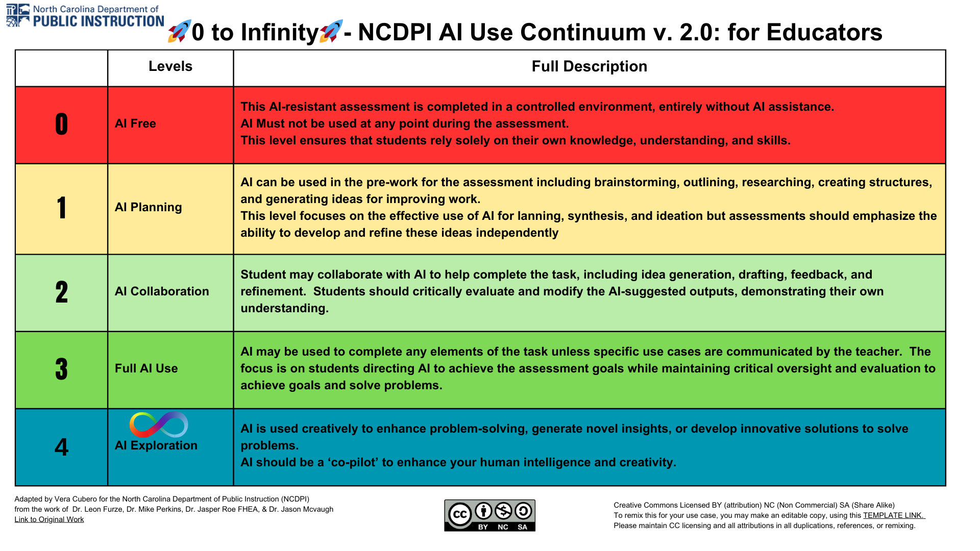
Download this image for printing or editing- go.ncdpi.gov/0toInfinity2.0

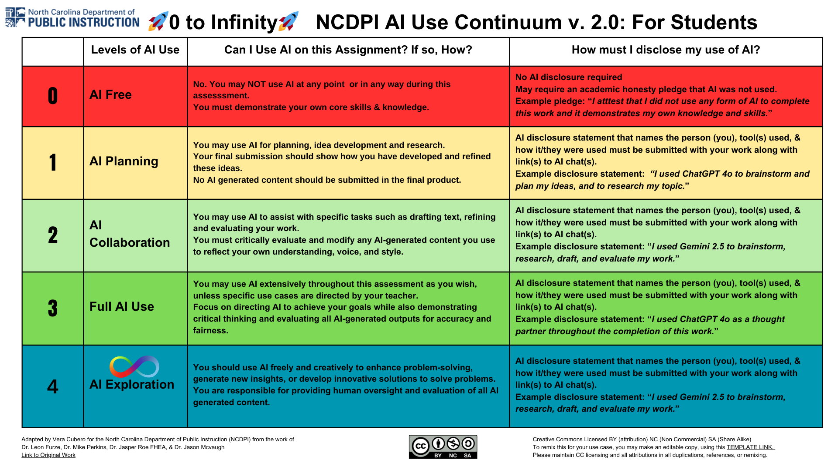
Download this image for printing or editing- go.ncdpi.gov/0toInfinity2.0

Use Great Caution with ‘AI Detectors’

AI detectors have proven not to be dependable, therefore they should never be used as the only factor when determining if a student ‘cheated’. Common issues with AI detectors are a high frequency of false positives for non native English speakers and creative writers as well as a high frequency of false negatives for students who are skilled at working with AI and are capable of fooling the detectors. If there is suspicion that a student depended on AI too heavily for an assignment, this should be viewed as a teachable moment to reinforce the appropriate partnership with AI tools rather than a ‘gotcha’ moment. Educators should ensure proper communication about appropriate uses of AI on each assignment, referencing an AI Acceptable Use Scale such as the one provided above to clarify appropriate level of generative AI as this may vary from assignment to assignment and class to class.
This graphic by Holly Clark of The Infused Classroom, is an excellent visual aid to demonstrate why AI detectors are problematic and what to do instead.

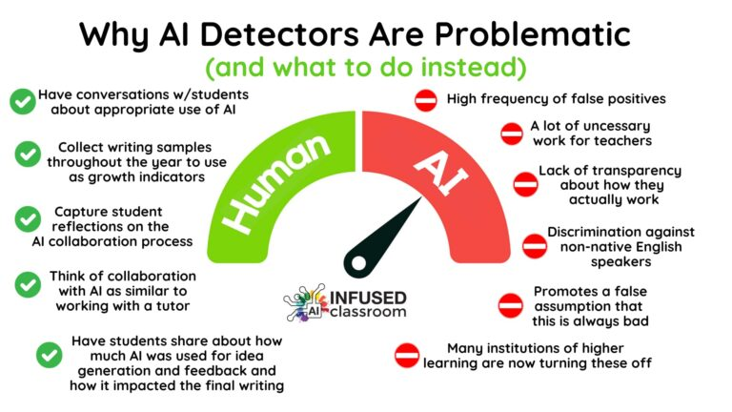
Image credit: Use with permission from Holly Clark of The Infused Classroom, https://www.hollyclark.org/2023/09/22/why-ai-detectors-are-problematic-and-what-to-do-instead/

By implementing these recommendations, North Carolina classrooms will transform into future-ready learning environments. Curriculum will be more interdisciplinary and project-centered, instruction will be
more accessible and personalized, and assessments will value growth and creation – all while AI humans alongside as a supportive co-creator. This balance ensures that we leverage what AI does best (information processing, tutoring at scale, idea generation) to unlock what humans do best (innovation, empathy,
judgment, collaboration). In sum, our goal is not to adapt education to AI, but to adapt education for the Intelligence Age empowering students to thrive with AI as confident, creative, and conscientious learners.In sum, our goal is not to adapt education to AI, but to adapt education for the Intelligence Age empowering students to thrive with AI as confident, creative, and conscientious learners.

Data Privacy & Cybersecurity

Data Privacy in the Age of AI
Protecting student data has always been a cornerstone of ethical education but in the Intelligence Age, this responsibility becomes even more complex. New AI tools not only process typed inputs but can now accept voice recordings, images, and even location data. These inputs are often stored by vendors for model training or product improvement, even when students or staff assume the data is private. Any AI system that collects, stores, or processes personally identifiable information (PII) including names, birthdays, voice clips, facial images, student work, or ID numbers must be subject to the same strict oversight as any traditional educational technology.

LLM models such as ChatGPT utilize user input in the form of chats to continue training the models. Therefore it is imperative that users fully understand NOT to enter, paste, or upload any PII into the chat of any generative AI tool. All users should be reminded of what data is considered PII, and that it includes student ID numbers. Users should use caution in particular to avoid inadvertently copying, uploading, speaking, or using computer vision to capture documents in an LLM as any of these methods couple potentially introduce PII into the model when evaluating student responses, analyzing data, or creating personalized content such as IEP goals, personalized learning plans, etc.

Under FERPA (Family Educational Rights and Privacy Act), PII includes both direct identifiers (e.g., name or Social Security number) and indirect identifiers (e.g., date of birth or student photo) that could be used to trace a student’s identity. Educators and students must be clearly instructed never to input PII into AI systems unless the tool has been formally vetted, approved, and integrated under local district policy.

Emerging AI-Specific Threats

Since our original publication in January of 2024, the capabilities of AI systems have grown exponentially. With new potential to improve our lives comes new emotional concerns as well as cyber security and data privacy risks that must be addressed by public schools in order to keep student data and students themselves safe from harm.
Modern AI systems introduce or increase several distinct risks not fully covered by older privacy frameworks:
- Voice-cloning scams – bad actors cloning a person’s voice to scam money
- “Social AI companion” chatbots – apps could potentially engage in sexual role-play, self-harm talk, and unhealthy emotional bonds
- Hyper-personalized political disinformation – deepfake videos/robocalls target users with tailored lies and propaganda
- Next-gen cheating & “ghostwriting” – Deep Research models auto-rewrite essays and evade detection
- AI-crafted cyberattacks on schools – phishing, ransomware, and spoofed video calls
- Impersonation & grooming – predators use AI to pose as peers or deploy bots that lure children in chat and games
- Mental-health over-dependence – teens turn to ChatGPT-style “therapy,” risking isolation and delayed professional help
- Deepfake harassment & image-based abuse – nude or hateful synthetic images/audio of classmates spread in seconds

AI Enabled Browsers
AI-enabled browsers represent a fundamental shift toward always-on, agentic computing. Embedding AI literacy across all curriculum areas and age bands in age-appropriate contexts will ensure every North Carolina learner can collaborate responsibly with these rapidly advancing systems while strengthening the higher-order competencies that remain uniquely human. AI-enabled browsers are the newest evolution of everyday digital tools, integrating conversational agents, tab-aware assistants, and multimodal reasoning models directly into web browsers. While these features can improve productivity, accessibility, and research efficiency for educators, they also expand privacy and data-security concerns in school environments. Because these tools are already becoming the default browsing experience, requiring clear oversight from district technology and policy leaders, we created the following guide, “AI-Enabled Browsers Are Here” to guide NC’s education and technology leaders in navigating this new shift. Note that this guidance will be updated frequently to reflect new advancements as tech companies address privacy and security issues.

Autonomous AI Systems
The recent viral release of the agentic platform, OpenClaw (was Clawdbot, then Moltbot) provides a preview into the potential future capabilities of agentic AI systems, and it has proven to introduce major security vulnerabilities.
Autonomous AI agents such as OpenClaw go beyond chatbots by taking direct actions on a device, including reading and writing files, browsing the web, and running commands, which increases the likelihood of unintended data exposure on school systems. Because these agents can be manipulated through prompt-injection or unvetted third-party “skills” to exfiltrate data or run malicious commands, Public School Units should:
- Treat them as a cybersecurity risk category and prohibit use on school-managed devices, accounts, or networks unless cleared through formal IT security review.
- Update Acceptable Use guidance to reflect this default prohibition and handle any detected use as a potential security incident (stop use, report, and triage).
- See the article “AI Insights Focus: What’s OpenClaw and why should I Care” by Matthew Wemyss Feb. 2, 2026 for a clear and easy to understand overview of OpenClaw.

Legislation Regarding Deepfakes
- On December 1, 2024, a new sex crimes bill, SL 2024-37/HB 591 came into effect in North Carolina, that includes significant provisions addressing the creation and distribution of nonconsensual deepfake images. This legislation aims to protect all individuals, including minors, from the harmful effects of this emerging technology. A key aspect of this law is that it treats AI-generated images, videos, or audio that recognizably imitate a particular person the same as real images or recordings for the purposes of these offenses.
- The TAKE IT DOWN Act has become law. This law compels platforms that host user-generated content to delete any non-consensual intimate image or an AI-generated “digital forgery” of such an image within 48 hours of a verified takedown request; knowingly posting this material becomes a federal crime punishable by up to three years’ imprisonment. The Act also treats a platform’s failure to maintain an effective notice-and-takedown process as an unfair or deceptive practice enforceable by the Federal Trade Commission.
- The Future of Privacy Forum published an amazing graphic and readiness checklist to help guide education institutions in navigating this challenging issue. The graphic can be viewed and downloaded by visiting this link

Recommended Actions to Safeguard against Deepfakes:

  - Educating Educators, Students, and Families: Provide comprehensive digital literacy (media literacy, online safety, social media literacy etc) that also includes information about deepfakes, and the potential ethical and legal consequences of creating, possessing, or sharing them. Emphasize that AI-generated content that is recognizably imitating a real person is treated the same as real content under the law and that punishments are harsher if the victim is a minor, even if the perpetrator is also a minor.
  - Developing Policies:
Implement clear school policies that address the creation and distribution of deepfakes, outlining specific consequences for students who violate these policies.
  - Collaborating with Law Enforcement: Establish procedures for reporting and addressing incidents involving deepfakes, working closely with law enforcement to ensure appropriate action is taken.
  - Supporting Victims: Provide resources and support services to students who are victims of deepfake pornography or other forms of online abuse.

Federal and State Compliance Requirements

- FERPA (Family Educational Rights and Privacy Act) ensures students’ education records remain protected.
- COPPA (Children’s Online Privacy Protection Act) prohibits data collection from children under 13 without explicit parental consent.
  - COPPA was significantly revised in January 2025, its first major update since 2013. These updates modernize the law to address new forms of data collection, including biometric data, AI-generated content, and automated profiling of children.
  - Key changes to COPPA include:
- Expanded Definition of Personal Information: COPPA now includes biometric identifiers such as facial recognition data and voiceprints.
- Parental Consent for Targeted Advertising: Separate, verifiable consent is now required before sharing data with third parties for personalization or profiling.
- Data Retention and Deletion Requirements: Data may only be kept as long as needed for educational or operational purposes, with written retention policies required.
- Stronger Notification to Parents: Schools and vendors must provide clear and accessible disclosures about data collection and sharing practices.
- New Consent Methods: New FTC-approved options include knowledge-based authentication, ID verification, and AI-assisted identity confirmation.
- Safe Harbor Transparency: COPPA Safe Harbor programs must now disclose membership lists and file compliance reports with the FTC.
- CIPA (Children’s Internet Protection Act) requires schools using federal e-rate funding to implement policies blocking inappropriate content and safeguarding against the unauthorized disclosure of student information.
- IDEA (Individuals with Disabilities Education Act) Ensures students with disabilities are provided with free appropriate education that is tailored to their individual needs.
- The use of AI as an instructional tool must be reasonable, appropriate, and individualized based on unique needs for students with disabilities.
- AI AI may provide options for expanding learning experiences through unique accommodations or as a supplement to assistive technology.
- Remember: The "I" in AI is not the same as the "I" in IDEA or IEP
- Section 504 requires that AI tools be accessible and non-discriminatory for students with disabilities, ensuring equitable participation in digital instruction.
In North Carolina, all third-party vendors connecting with the NC SIS and other state-wide systems must comply with DPI’s Third-Party Data Integration Requirements, effective January 2024. These include mandatory Data Confidentiality and Security Agreements and alignment with NIST 800-53 cybersecurity standards. Districts must maintain documentation confirming that vendors use student data only for educational purposes and do not share or monetize it without consent.

Cybersecurity Considerations for AI Tools

AI tools can expose districts to new cybersecurity risks, including unauthorized data extraction, prompt injection attacks, and potential leaks of sensitive content.
PSUs should conduct and review a security audit on the product/vendor to ensure they meet or exceed applicable security practices, PSU, State, and Federal requirements. PSUs should understand how each product or tool harvests data for training and continual learning. This is critical to help ensure sensitive data or contaminated data is not ingested. District technology teams must audit each tool’s security posture before adoption:
- Ensure Encryption
- Limit Permissions
- Avoid Model Training on School Data
- Use Simulated Data for Pilots
- Establish Incident Response Protocols
Districts are also encouraged to monitor vendor updates. Many AI tools update their terms of service frequently. A product that was offline yesterday might now sync data to the cloud. These changes may expose students to new risks and should trigger re-review before continued classroom use.

Reviewing and Adapting Guidelines
School districts and schools must continuously review and adapt their AI guidelines to keep pace with the rapid evolution of AI technologies. This involves regular assessments of AI practices, potential risks, and emerging trends to maintain responsible and ethical integration. All PSUs engaging with AI technologies should regularly review the company’s usage and privacy guidelines.
Usage: PSUs, schools, educators and students that are utilizing any type of AI tools adhere to specific usage requirements outlined by the tool's developer or provider. This includes complying with age restrictions, data usage practices, any restrictions, inclusivity, limitations, notifications, and any other relevant guidelines or restrictions. This should include awareness and procedures in place regarding, but not limited to following COPPA, CIPA, IDEA, FERPA, and section 504.

Transparent Communication with Families

Perhaps most importantly, schools must communicate clearly and consistently with families about how AI is being used, what data is being collected, and how it is protected. Best practices include:
- Publishing a list of approved AI tools used in classrooms by grade span.
- Including AI in annual technology disclosure forms and the list of “School Officials” in the annual FERPA notification .
- Holding family information sessions on AI safety and literacy.
- Providing opt-out options where appropriate.
- Explaining how voice, video, or images may be used, and when parental consent is required.

Technology, Infrastructure, and Devices

Purchasing and Using AI Technologies:
When it comes to investing in technologies to support learning with and about Artificial Intelligence, it is important to ensure that the technology resources:
- Are Age Appropriate for the User of the AI Technology:
  - Pay special attention to age allowances of the technology to ensure compliance with federal, state, and local laws and policies as well as age limits and permission requirements in the terms of service for each application.
- Comply with Regulations:
  - Prioritize technologies that comply with federal, state, and local regulations regarding data privacy and cybersecurity in educational settings. Familiarize yourself with regulations like the Family Educational Rights and Privacy Act (FERPA) in the United States and similar laws in other regions.
- Secure Access Controls:
  - Implement secure access controls to ensure that only authorized individuals have access to sensitive student data. This includes usernames, passwords, and multifactor authentication methods to protect against unauthorized access.
- Encrypt and Secure Transmission:
  - Ensure that data, especially personally identifiable information (PII), is encrypted both in transit and at rest. This adds an extra layer of protection against data breaches or unauthorized interception.
- Are Required to Undergo Regular Security Audits:
  - Periodically conduct security audits and assessments to identify vulnerabilities in the technology infrastructure. This helps in proactively addressing potential security risks and ensuring a robust cybersecurity posture.
- Meet Clear Data Usage Policies:
  - Clearly communicate to students, parents, and educators how data collected by AI technologies will be used, stored, and shared. Establish transparent policies that align with best practices for data privacy in educational settings.
- Meet Vendor Security Standards:
  - If using third-party platforms or services, verify that the vendors adhere to stringent security standards. This includes evaluating their data protection policies, encryption practices, and overall commitment to cybersecurity.

Seven Questions to Ask Generative Ed Tech Companies
- AI Capabilities and Limitations
Generative AI is a new technology with extensive limitations.
  - What controls are in place to identify and lower hallucinations?
  - Are responses accompanied by links to reliable sources to verify the information?
  - Does the tool include teacher monitoring or an easy way to share the AI Chat so teachers can monitor student use for school work?
- Mitigating Bias
It’s important that the tools we use do not cause harm to our students or teachers.
  - What steps have been or are being taken to identify and mitigate biases?
  - How are fair and unbiased outputs supported?
  - How can users report instances of bias if they encounter them in AI responses?
- Student Privacy and Ethical Data Use
Protecting student data privacy and ensuring ethical use of data is a top priority for our school.
  - What policies and safeguards are in place to address privacy of student data?
- Human Oversight and Quality Control
Our educators need to validate and trust AI-generated content before use and ensure there is always a human in the loop.
  - What human oversight and quality control measures are used?
  - How is feedback from teachers/students being collected and actioned?
- Evidence of Impact
  - We need evidence that your AI tool will improve learning outcomes for our student population and/or effectively support our teachers.
- Accessibility and Inclusive Design
Our school needs to accommodate diverse learners and varying technical skills among staff.
  - How does the tool ensure accessibility and usability for all our students and staff?
  - How can these tools be used to provide additional support and personalization for students with IEPs, 504s, Multilingual Learner (ML) economically disadvantaged students, marginalized student groups and others?
- Cybersecurity
  - How can we be sure we are minimizing any potential risks to our networks and our users?
  - What security practices are you implementing to protect our user and organizational data (an essential act of AI project management & digital citizenship)?
  - How do your security practices meet or exceed applicable PSU, State, and Federal requirements including the new NC Third Party Data Integration requirements?AI Evaluation Tools:
- District/PSU Level- AI Evaluation Tool- Created by NC AI Collaborative members, Marty Sharpe, David Blattner, Daven Hunsicker, Orhan Kul, Melody Lam, Dane Rickett, Casey Rimmer, Susan Rodgers, & Dale Rush
- EdTech Evaluation Tool from EdTech Center @ World Education Workforce EdTech Tools

Appendix A: AI Literacy Timeline

From AI Awareness to AI Fluency: NCDPI AI Literacy Timeline PK–13 and Educators: v. 2.0

Download this image for printing [go.ncdpi.gov/NCAILitTimelineImage ]

NCDPI’s recommended progression of AI-related skills in education can be structured into three developmental buckets: AI Awareness, AI Literacy, and AI Fluency, with alignment to the Knowledge, Skills, and Attitudes (KSAs) and the Four Domains of AI Literacy from the international AI Literacy Framework, “Empowering Learners for the Age of AI -Review Draft May 2025.

Knowledge, Skills, and Attitudes
- Knowledge – what learners understand about AI systems and data
- Skills – what learners can do with and around AI, including core literacy and computational thinking
- Attitudes – the mindsets that guide safe, ethical, curious engagement

The Four Domains of AI Literacy (Empowering Learners for the Age of AI- review Draft May 2025)
Engaging with AI involves using AI as a tool to access new content, information, or recommendations. These situations require learners to first recognize AI’s presence, then evaluate the accuracy and relevance of AI
outputs. Learners must develop a fundamental understanding of AI’s technical foundations to critically analyze its capabilities and limitations.

Creating with AI consists of collaborating with an AI system in a creative or problem-solving process. It involves guiding and refining AI output through prompts and feedback, while ensuring the content remains fair and appropriate. It also involves ethical considerations related to content ownership, attribution, and the responsible use of existing materials.

Managing AI requires intentionally choosing how AI can support and enhance human work. This includes assigning structured tasks to AI, such as organizing information, so humans can focus on areas requiring creativity, empathy, and judgment. AI systems can simulate a variety of roles, acting as an analyst, debate partner, or career guide. Learners who manage AI’s actions learn to delegate tasks thoughtfully, guide AI outputs with clear instructions, and assess whether AI’s role aligns with their goals and values. This domain helps learners build agency, ensuring that AI works for them and that its use remains ethical and human-centered.

Designing AI empowers learners to understand how AI works and connect it to its social and ethical impacts by shaping how AI systems function. Through hands-on exploration in an education context, students examine how data, design choices, and model behavior influence the fairness, usefulness, and impact of AI systems. The goal is not to develop commercial products or put them into service, but to build the confidence and capacity to shape AI for human good by understanding the principles underpinning the design of AI from an early age.

The goal is to ensure age-appropriate, safe, and meaningful integration of AI, starting with simple awareness in early years, beginning AI literacy in upper elementary, building on that understanding in middle school, and achieving AI fluency in high school and beyond. Below is a breakdown of each bucket and grade band, with descriptions and practical examples for implementation.

AI Awareness: Learn ABOUT AI; focus on literacy (Grades PK–5)
In the AI Awareness stage, the emphasis is on exposing students to the concept of AI in everyday life without having them directly interact with AI chatbots. Early elementary remains a literacy‑first zone. Students notice helpful technologies (voice assistants, smart toys) and discuss how those tools follow human instructions. Online or unplugged robot or coding games, pattern‑spotting, or teacher‑driven discussion and image‑comparison activities nurture AI literacy while also building critical thinking skills.
**Direct chatbot use is not recommended for students at this age. Because early-elementary children are still learning to separate make-believe from fact, exposing them to lifelike AI chatbots can blur that boundary, causing them to mistake scripted fantasies for truth, form one-sided “friendships” with chatbots, or follow unsafe guidance they cannot yet critique. Until their reality-checking skills mature, it is safest to keep chatbots out of this age group’s hands. Remember that these are recommendations, not mandates. We realize that some PSUs have done considerable work on developing AI literacy and may be further along in their journey. Each PSU may determine its own guidelines and policies.
Update: AI-literate educators in grades PK-5 may garner student input to generate AI images and stories as well as demonstrate the use of AI chatbots for students, while modeling effective use and human oversight but students should not engage directly with the chatbots.
At this level, students learn about AI indirectly, but should not learn with AI.
- The educational focus should be on building literacy- reading, writing, and listening skills, as well as mathematical literacy and media literacy are all integral to future learning as well as successful interaction with AI systems. Effective and ethical use of AI requires a strong foundation in all forms of literacy (reading, writing, speaking, mathematical & media literacy). Therefore, literacy should be the foundation and focus of the PK-2 AI literacy curriculum.
- Young children are not developmentally ready to critically evaluate AI outputs for accuracy or bias, which could result in potentially harmful outcomes.
- Introduce basic concepts such as what AI is and how it appears in the world around them.
- Even at this young age, children can begin forming an understanding that AI is a technology in their lives, without interacting with chatbots.
Example AI Awareness Activities for Grades PK-5:
- Discuss AI in daily life in an age-appropriate way.
  - Discuss how virtual assistants or smart speakers work when answering a question (without having students directly ask the device themselves). This builds awareness that some machines can "talk" or respond based on data.
- Develop media literacy and build awareness of AI-generated content by showing how images or videos can be digitally altered using AI tools.
  - Show two pictures (one real, one AI-altered) and help students spot differences to cultivate a healthy skepticism of digital media.
  - Involve students in AI-generated images for their stories using an education-friendly AI art generation tool like Adobe Express or Canva. A teacher can generate an illustration for a story based on ideas from the students (students suggest characters or settings, the teacher inputs these into the AI tool so the students can see the AI generation process).
- Introduce fundamental computing concepts through play. Activities like basic coding games or robots let young children give instructions to a machine and see it act, which is a
precursor to understanding how AI follows instructions. These offline or tangible tech activities build computational thinking without needing an actual AI chatbot.

AI Literacy: Learn ABOUT and WITH AI (Grades 6–8)

Middle‑schoolers transition from passive awareness to active understanding. Lessons progress to build a deeper understanding of how models work, concerns and considerations of AI, why bias arises, and how AI models may impact society. Classroom use shifts to the structured investigation, such as comparing two LLM answers, debugging model hallucinations, or debating an algorithmic fairness case.
- Knowledge: Model architecture basics, bias mechanics, environmental impact.
- Skills: Prompt design, source verification, societal impact reasoning.
- Attitudes: Responsibility, empathy for affected communities.
All tasks are scaffolded; every AI output is annotated and cross‑checked before acceptance.
- Middle schoolers may be allowed to engage with age-appropriate AI chatbots under teacher direction, always with a critical eye.
- All interactions should be heavily scaffolded to support the development of AI Literacy
- Educators teach, model, and reinforce appropriate, safe, and ethical use of AI tools.
- Key objectives for this stage include: demystifying AI technology, practicing critical evaluation of AI outputs, learning how to formulate good questions or prompts, and understanding ethical use (such as avoiding plagiarism, respecting privacy, and knowing the limits of AI answers).
- Students also continue to build on digital citizenship skills, now applying them to scenarios involving AI.

Example AI Literacy Activities for Grades 6-8
- Evaluate AI outputs for bias or inaccuracies: Incorporate activities where students see AI’s limitations first-hand. Using a pre-curated example, show a scenario where an AI gave a biased or incorrect response. Middle schoolers can work to identify what’s wrong and talk about why the AI might have said that. This could involve comparing an AI-written paragraph with a human-written one on the same topic to spot differences in tone or content.
- Media literacy with AI content: Expand on earlier media literacy by introducing tools like Which Face is Real? or deepfake videos to challenge students to discern AI-generated content. By gamifying the detection of AI vs real images or news, students sharpen their critical observation skills. After such games, tie it back to chatbot text outputs: just as images can be faked, text can include false information that sounds confident.
- Responsible prompting and use: Teach students how to craft clear prompts and questions for AI and why that matters. For example, demonstrate how a vague question can produce a useless answer, whereas a specific question yields better information.
- Ethical discussions: Engage students in thinking about the ethics of AI. Pose hypothetical scenarios: “If you use an AI chatbot to help with your homework, what responsibility do you have to check its work?” or “What if the AI says something mean or wrong – whose fault is that?” These discussions make them reflect on accountability and fairness, reinforcing that AI is a tool that requires human judgment at all times.
Throughout middle school, students learn with AI in a limited, controlled fashion after they have learned about it. Teachers act as moderators and co-pilots whenever AI tools are used. By the end of 8th grade, students should be comfortable with the idea of AI as a tool and have the skills to critically evaluate AI-generated content. They should also understand the privacy and safety aspects – for example, why most AI tools require users to be 13 or older, and why we don’t put personal information into a chatbot.

AI Fluency: Working ALONGSIDE AI (Grades 9–13 and Educators)
In the AI Fluency stage, by high school, AI becomes a “thinking partner.” Students co‑write research outlines, feed local datasets into no‑code builders, or prototype chatbots that serve community needs. The focus here is on effective and ethical co-creation with AI. Students and teachers move from simply understanding AI to leveraging AI collaboratively – like an apprentice working with a smart assistant.
- Knowledge: Governance, intellectual‑property limits, system design trade‑offs.
- Skills: Advanced prompting, iterative co‑creation, portfolios with metacognition.
- Attitudes: Transparency, lifelong learning, agency.
All users must practice responsible use with oversight and documentation. Data privacy and student safety is paramount. Ensure that students and educators are well trained in the concerns and limitations of generative AI and how to protect data privacy, and that they teach and model safe and ethical use to students, including never putting PII (Personally Identifiable Information) into an AI tool.
Transparency is important to building a culture of academic integrity and trust. Students and educators should openly disclose when and how they have used AI in creating any content. Ethical use also means recognizing when NOT to use AI (for instance, on an assignment meant to assess personal learning), and ensuring AI contributions do not introduce plagiarism or false information. Educators at this level should provide clear guidelines for AI use in coursework and model those guidelines themselves.

AI as a creative partner: Encourage students to use AI tools to brainstorm ideas, draft content, or solve problems – and then refine the output with their knowledge and style.
- A 10th grader writing a research paper might ask ChatGPT (or a school-sanctioned LLM) to suggest an outline or to generate a list of sources on a topic. The student then evaluates those suggestions, checks the sources for credibility, and writes the paper, perhaps even asking the AI for feedback on a draft.
Project-based learning with AI: At this level, assignments can integrate AI meaningfully. A possible class project could be to build a simple chatbot or AI app for a purpose –
- Students train a small AI model (using a tool or a predefined dataset) to categorize articles or to respond in a specific style. While building a full AI from scratch is advanced, there are user-friendly platforms where students can adjust an AI chatbot’s knowledge base.
- Students create a short video, presentation, or solution to a local issue with the assistance of AI tools (like using AI to generate music or visuals for a student-made video, then discussing the process in class).
Critical evaluation and oversight: Even as students use AI more independently, they must keep their critical thinking on high alert. Teachers should frequently remind and require students to fact-check any AI-generated content.
  - The student uses an AI assistant to get information for a history project and verifies those facts with primary or reputable sources. Consistent with the Engaging domain, users must practice critical evaluation of bias/hallucination before accepting any output.
Ethics and accountability measures: High schoolers and educators should follow a clear code of conduct for AI use. Schools may have policies such as: any use of AI on an assignment must be cited or acknowledged, and AI should not be used when it would undermine the learning objectives.

Appendix B: 0 to Infinity Framework

0 to Infinity: NCDPI AI Use Continuum v. 2.0

Educator Version:
Download this image for printing or editing- go.ncdpi.gov/0toInfinity2.0
Level 0 – AI Free
At this foundational stage, students rely solely on their own thinking, knowledge, and skills. By working independently and without AI assistance, they build essential cognitive habits, such as personal problem-solving, self-reliance, and academic integrity. This level creates a clear baseline from which authentic growth and responsible AI integration can later be measured.
Level 1 – AI for Planning
In this stage, AI is introduced as a thought partner in the earliest stages of the creative and learning process. Students use AI to brainstorm, organize, and explore ideas, sharpening their ability to generate and structure potential solutions while still producing original final work. AI serves as a planning scaffold, helping students clarify their direction without building the final product.
Level 2 – AI Collaboration
At this level, AI and students work together in a collaborative loop. Students engage with AI for drafting, refinement, and feedback but remain the decision-makers, critically evaluating and shaping all outputs. AI is no longer just a brainstorming tool; it becomes an interactive partner that helps students test ideas, identify flaws, and strengthen their solutions while maintaining their personal voice and understanding.
Level 3 – Full AI Use
In the AI Fluency stage, students use AI as a strategic partner throughout the entire process, setting goals, generating content, solving problems, and refining results. The focus is on mastering the art of directing AI to meet specific learning and creative objectives, while maintaining critical oversight. Here, AI is a trusted collaborator helping students tackle complex tasks, expand their thinking, and build real-world solutions with purpose and precision.
Level 4 – AI Exploration
This is the transformative zone, where students use AI as a launchpad for innovation. AI is not just assisting its enhancing their human creativity to solve complex problems, generate novel ideas, and envision entirely new possibilities. Students use AI to push boundaries, not just complete tasks, and engage with it as a tool to design, iterate, and invent solutions that didn’t exist before.Use Great Caution with AI Detectors

Try it Out: ) to Infinity Teacher Tool

This GPT will help teachers internalize how to create learning experiences along the 0 to Infinity continuum. The GPT was created by Vera Cubero, NCDPI, and is free to use.
- go.ncdpi.gov/0toInfinityGPT (v2.0)

How to use the 0 to Infinity Scale Teacher Edition
Use this teacher poster as the back-of-house playbook guiding equitable, developmentally appropriate AI integration while the student version keeps day-to-day expectations clear and consistent for learners.
Implementation tips for AI-literacy instruction
- Embed in curriculum maps. Annotate units with the intended AI level so PLC teams share common expectations.
- Co-plan transparency. Show students the student poster alongside your assignment sheet; explain why you selected that level.
- Model process evidence. Collect outlines, drafts, or chat links at Levels 2–4 to assess thinking, not just the final product.
- Differentiate gradually. Start the year with Level 0 or 1 assessments; progress to Levels 3–4 as learners gain skills in collaborating with AI, AI use disclosure, verification, and ethical use.
- Reflect & recalibrate. After each assessment, debrief with students and colleagues: Did the chosen level promote the targeted skills? Adjust rubric language or safeguards as needed.

Student Version:
Download this image for printing or editing- go.ncdpi.gov/0toInfinity2.0
NOTE- this download file includes access to custom GPT and Gem for training as well as the previous version (version 1.0)
How to use the 0 to Infinity Continuum Student Edition
This student-facing chart is a student-friendly companion to the teacher version. Both posters list the same five levels (0 = “AI Free” through 4 = “AI Exploration”), but the student version:
- omits the assessment-design guidance found on the teacher version and instead focuses on what students must do (plan, collaborate, cite, evaluate).
- uses short prompts so learners can see at a glance what is and is not allowed on a given task;
- adds a third column with disclosure requirements and examples

Appendix C:CRAFT 2.0 Framework

The CRAFT 2.0 Prompting Framework with 3 Power Ups
While improved AI technology makes prompting frameworks less necessary, users can have much more productive and safe interactions with AI by ensuring they provide enough context to guide the models. Providing structure and context in prompts often yields responses that are on-topic, accurate, and classroom-appropriate. Many educators find it useful to examine exemplar prompts such as those in the AI for Education Prompt Library, which offers over 100 high-quality prompt examples for various classroom scenarios. Ultimately, learning to communicate your needs to an AI and to critically evaluate the AI’s output is now a core competency. It’s a skill best learned by doing, so teachers and students should be encouraged to experiment with prompts and share what works.
The CRAFT 2.0 framework builds on the original CRAFT model with a few updates and 3 “Power-Ups” to better reflect the capabilities of today’s large language models. The accompanying CRAFT 2.0 with Power Ups poster may be downloaded and printed as a teaching tool when educating staff and students on how to communicate effectively with AI models.
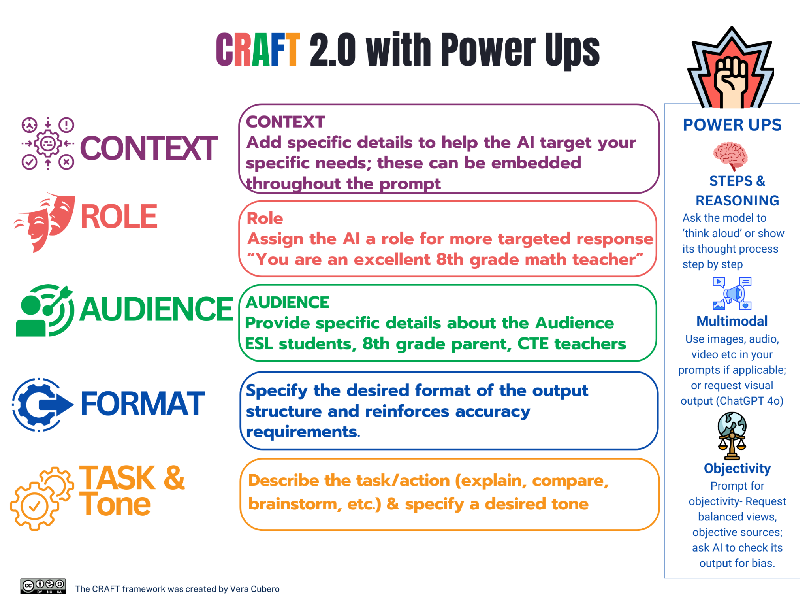
Download this image for printing- https://go.ncdpi.gov/CRAFT-2.0

Try it out!
Try the CRAFT 2.0 Framework with Power Ups Interactive Teaching Guide to help understand this prompting framework - https://go.ncdpi.gov/CRAFT2.0_Guide (Accessible to all who can access claude.ai/public/artifacts….)

Appendix D: Acceptable Use of AI for Special Ed

Technical Assistance: Acceptable Use of AI for Special Education Teachers and Related Service Providers
Aligning with the NCDPI Generative AI Implementation Recommendations and Considerations for PK-13 Public Schools

Acceptable Use of AI for EC Staff Version History

Date | Version | Changes and Updates
11/05/2025 | 1.0 | TA Launched and shared with EC Administrators

Introduction
Artificial intelligence (AI) offers significant opportunities to enhance educational practices for students with disabilities. When used responsibly, AI can support teachers and related service providers in managing workloads, analyzing data, and creating engaging, differentiated instruction. This document serves as comprehensive guidance to help special education professionals navigate appropriate and ethical applications of AI tools while maintaining rigorous standards and compliance with privacy regulations.

Purpose and Rationale for AI in Special Education
While AI can serve as an initial drafting aid for Present Levels of Academic Achievement and Functional Performance (PLAAFPs) and measurable SMART IEP goals, the decision for staff to utilize such tools rests with each local Public School Unit (PSU). Further the use should be conditional upon the appropriate knowledge of exceptional children processes, the characteristics associated with suspected or identified disabilities, and a deep understanding of the educational implications for using data from various assessment sources followed by a rigorous human review and personalization.
The Office of Exceptional Children (OEC) is committed to providing high-quality guidance on the education of all students, including equipping staff with the knowledge necessary to leverage emerging technologies in a meaningful and safe manner.
When used ethically and effectively, AI can serve as a valuable resource to:
- Bridge Resource Gaps: AI can provide teachers and related service providers with access to expertise and a wider range of strategies that might otherwise be unavailable, helping to level the playing field.
- Enhance Quality: By providing well-structured, measurable, and standards-aligned goal suggestions, AI can assist in the development of more robust and individualized IEPs. Any AI suggestions must be reviewed by the instructional staff who know the student best who should refine and personalize these suggestions prior to their utilization.
- Strengthen Individualization: The utilization of AI in the drafting of PLAAFPs and SMART IEP goals has the ability to enhance individualization by leveraging the AI's ability to analyze multiple data points that have been anonymized (removing all PII) and follow local policies and procedures to help process and draft complex student profiles. This can include student data such as assessment scores, academic records, attendance, and previously documented learning preferences. Additionally, it has the ability to generate diverse goal options based on the student's specific learning styles, interests, and developmental levels.

Core Framework: Human-AI-Human (H-AI-H) Model
(Washington State Office of Superintendent of Public Instruction - 2024)
All AI-assisted IEP development and special education practices should follow the Human-AI-Human framework. This model ensures that human expertise and oversight remain central to the process, with AI serving as a supportive tool.
Human-AI-Human (H-AI-H) Workflow
- Human Inquiry: The process begins with human-initiated prompts based on anonymized comprehensive student data, that contains no Personally Identifiable Information and uses professional judgment.
- AI Assistance: AI provides initial drafts and suggestions as a support tool.
- Human Review and Finalization: Educators critically review, revise, and ensure all content meets individualized needs and legal standards.

Key Considerations for AI Use in Special Education
Special education teachers and related service providers must adhere to the following principles when integrating AI into their professional practice:
- Adherence to Local Policies: Staff should consult and comply with their district's policies regarding AI use and data privacy.
- Protection of Confidentiality: Personally identifiable information (PII) and confidential student records must never be entered into AI systems.
- Human Oversight: AI should be viewed as an assistive tool rather than a decision-maker, with professionals critically evaluating AI-generated content.
- Professional Judgment: Special education documentation requires professional judgment, individualized assessment, and direct knowledge of each student's unique needs.

Understanding Appropriate vs. Inappropriate Uses of AI
The following guidelines will help you navigate the appropriate use of AI tools in your professional practice.

Appropriate AI-Assisted Drafting
Definition: The use of artificial intelligence to help generate initial text or ideas that a human then reviews, edits, and finalizes. The AI functions as a support tool, not as the final authority or decision-maker.
Characteristics:
- Human-initiated through carefully crafted prompts. Examples of carefully crafted prompts include: "Draft a measurable SMART goal for a 5th-grade student with a specific learning disability in reading comprehension, based on their recent reading assessment score of 20th percentile, focusing on identifying main ideas in narrative texts." An example of a less effective prompt might be: "Write a reading goal for a student."
- AI provides a starting point only (e.g., draft PLAAFP or IEP goal).
- The human maintains full control, accountability, and authorship.
- All content undergoes rigorous educator review and revision.

Inappropriate Automated Decision-Making
Definition: When an AI system makes determinations or recommendations without meaningful human involvement in evaluating, modifying, or approving the output.
Why This is Prohibited:
- Lacks individualized consideration required by IDEA.
- Risk of algorithmic bias affecting vulnerable students.
- May violate FERPA and other legal requirements.
- Removes essential human judgment from special education decisions.

Appropriate Uses of AI
AI tools can effectively support the following aspects of special education service delivery:
- IEP Goals and Present Levels:
  - Generating initial PLAAFP wording from educator-provided student data.
  - Drafting SMART goal suggestions aligned with assessments and standards.
  - Rephrasing performance descriptions for family-friendly language.
  - Creating goal scaffolds based on grade-level expectations and student needs.
  - Designing meaningful and obtainable benchmarks to help ensure student progress towards meeting IEP goals.
- Instructional Support:
  - Lesson Planning: Generating differentiated lesson plans aligned with curriculum standards.
  - Differentiated Activities: Creating varied activities around common themes to meet diverse learning needs.
  - IEP Implementation Support: Generating instructional materials that align with student needs and goals.
  - Universal Design for Learning (UDL) Alignment: Supporting differentiated instruction by generating alternative lesson formats, adapting content to different learning preferences, and providing multimodal access to instruction.
  - Task Analysis and Breakdown: AI can help break down complex tasks into discrete steps for instruction and creating visual supports for sequencing tasks.
- Data and Communication Support:
  - Data Analysis: Identifying patterns in student performance data and creating visuals of the data.
  - Multilingual Support: Providing translations for students and families with diverse language backgrounds (It is important to note that AI translations are not always 100% accurate and are not a replacement for existing translation services and practices).
  - Administrative Support: Assisting with clerical tasks and administrative documentation.
  - Scheduling: Assisting in managing appointment and session scheduling efficiently.
  - Suggesting evidence-based strategies and interventions.

Considerations for the use in Practices:
- Using AI as a starting scaffold with final decisions grounded in multidisciplinary team input.
- Iterating between AI suggestions and professional judgment.
- Cross-referencing AI outputs with current research and best practices to ensure alignment with effective instructional strategies (e.g., checking resources from professional organizations, academic journals, higher education institutes or federally funded technical assistance centers).

Inappropriate Uses of AI
The following uses of AI are considered inappropriate and should be avoided:
- Automated Content Finalization: Finalizing any IEP content without thorough educator validation. This includes submitting AI-generated content without substantial human review and modification (e.g., simply copy-pasting AI output without critical evaluation, customization, or significant edits to ensure alignment with the student's unique needs).
- High-Stakes Decision Making:
  - Allowing AI to determine student eligibility for services.
  - Making high-stakes decisions related to disciplinary actions, or educational placements.
  - Using AI to interpret assessment results or make placement recommendations.
- Replacing Professional Judgment in Core Documentation:
  - Writing Evaluation Reports: AI-generated reports may lack the nuance required for legally sound documentation.
  - Creating Progress Reports: Student progress monitoring requires professional judgment and educator-collected data.
- Student Data Misuse: Using AI tools that store personally identifiable information externally, including cloud-based AI tools where data is processed and stored on the vendor's servers without explicit, secure contractual agreements.

Privacy and Security Requirements
IMPORTANT: Everyone should adhere to district policies regarding data privacy and protection of confidential information.

Data Protection Standards:
- Anonymize All Input: Remove all personally identifiable information (PII) before using AI tools. PII includes, but is not limited to, student names, specific dates of birth, addresses, unique student identification numbers, and names of family members.
- Use Generic Descriptors: Reference "a 3rd-grade student with reading difficulties" rather than student names. For example, instead of "John scored 70 on his math assessment," use "A 7th-grade student scored below proficiency on a recent math assessment".
- No External Storage: Ensure AI tools do not retain or store student information, even if anonymized. Ensure chat histories are turned off when possible.

Before using any AI tool:
- Consult your district's technology policies regarding approved AI platforms.
- Never input student names, ID numbers, or other personally identifiable information.
- Use anonymized or generalized information when seeking AI assistance.
- Document all AI usage in accordance with local procedures.
- When in doubt, consult with your local leadership.

Quality Assurance and Professional Standards

Human Oversight Requirements:
- Certified Special Education Teacher Review: All AI-generated content should be reviewed by qualified special education staff.
- IEP Team Validation: Content should align with team consensus and multidisciplinary input.
- Student-Specific Customization: Generic AI outputs should be thoroughly individualized.
- Legal Compliance Check: Ensure all content meets IDEA, Section 504, and local requirements.

Professional Judgment Standards:
- Educators should critically evaluate all AI suggestions against their knowledge of the student.
- Professional expertise and understanding of student context takes precedence over AI recommendations.
- AI outputs serve only as a starting point for professional decision-making.
- Final content should reflect the educator's professional standards and ethical obligations.
- AI tools should enhance, not replace, your professional expertise. Always prioritize student privacy, individualized needs, and your professional judgment when incorporating technology into special education services.

Documentation and Transparency

Suggested Documentation:
- When using AI-generated content, document this in your records.

Transparency Measures:
- Maintain clear records of which sections utilized AI assistance.
- Document the extent of human modification and review.
- Ensure families understand that human professionals maintain full responsibility for IEP content.
- Any use of AI should be disclosed when applicable, and families should be informed of its role in education.
- Annual compliance audits to verify proper implementation.

Training and Professional Development

Suggested Training Components:
- H-AI-H Implementation: Understanding the Human-AI-Human workflow and its critical phases.
- Effective Prompt Design: Creating specific, relevant prompts that yield useful outputs, including practical exercises and examples of strong vs. weak prompts.
- Bias Detection and Mitigation: Identifying and addressing potential algorithmic bias in AI outputs, with strategies for critical review.
- Privacy Protection: Maintaining confidentiality while using AI tools, including detailed guidance on anonymization and PII.
- Quality Review Processes: Systematic approaches to evaluating and improving AI-generated content, including checklists or rubrics for review.
- Staff should participate in professional development as outlined in NCDPI's broader AI guidance to build competency in ethical AI use.

Ongoing Professional Development:
- Regular updates on new AI tools and capabilities.
- Case study reviews of successful AI-assisted IEP development.
- Collaborative sessions on prompt refinement and output improvement.
- Legal and ethical updates related to AI in special education.

Implementation Scenarios
The following examples demonstrate how AI can serve as a tool to enhance professional practice while maintaining ethical standards, protecting student privacy, and upholding professional judgment.

Task | Appropriate Approach | Inappropriate Approach
Draft a PLAAFP section for a student with specific academic needs. | Input anonymized student data into an approved AI tool with a prompt like "Draft a PLAAFP section for a 4th-grade student struggling with multi-step word problems, incorporating their strength in computation." The educator then reviews, edits, and adds specific qualitative observations and team input to finalize the PLAAFP. | Copy-pasting a student's full name and specific assessment results directly into an AI tool, or accepting an AI-generated PLAAFP without significant human review and customization.
Creating materials for a student with reading difficulties | Using an approved AI tool to generate varied reading passages at the appropriate level, where educators review and select the most suitable passages, then facilitate student engagement with the customized content. | Using AI to write specific reading goals for the student's IEP.
Supporting a multilingual student | Using an approved AI tool to translate instructions or create dual-language materials, with teachers verifying accuracy and cultural appropriateness before implementing the materials in their multilingual classroom instruction. | Using AI to assess language proficiency or write reports.
Data collection | Using anonymized data free from PII and an approved AI tool to organize and visualize assessment data patterns, enabling educators to interpret the insights and design targeted interventions that address individual student learning needs. | Using AI to interpret assessment results or make placement recommendations.
Parent communication | Using an approved AI tool to check grammar/clarity in parent communications (without PII), with educators reviewing the suggestions and personalizing the final message to maintain authentic family relationships. | Using AI to write progress reports or assessment interpretations.
Speech therapy | Using an approved AI tool to generate activities that target specific linguistic concepts for articulation practice, while speech-language pathologists select and modify exercises based on individual student assessment needs and progress monitoring. | Using AI to write progress notes or determine therapy goals.
Movement-based Instruction | Using an approved AI tool to generate lesson plan ideas which incorporate movement, with teachers adapting and implementing the activities based on their students' developmental needs and classroom environment. | Using AI to determine which students need movement-based interventions or to create complete motor skill development plans without professional expertise.
Universal Design for Learning (UDL) | Using an approved AI tool to generate multiple presentation formats and assessment options for a lesson on local government, allowing educators to select and customize the most appropriate options for their diverse learners' needs and learning styles. | Using AI to determine specific student learning needs or accommodations.
Task Analysis and Breakdown | Using an approved AI tool to break down complex tasks like using a combination lock, with occupational therapists creating specific adaptations based on individual student motor skills, sensory needs, and IEP goals. | Using AI to write goals for task completion or determine student placement.
Social emotional learning | Using an approved AI tool to generate SEL discussion prompts, role-play scenarios, or reflection questions that align with established SEL frameworks, while counselors and teachers facilitate meaningful conversations and adapt activities to their students' social-emotional development levels. | Using AI to diagnose students' emotional states or generate personalized intervention plans for students experiencing social-emotional challenges without professional oversight.
Maximizing the scheduling of student service delivery | Using an approved AI tool to organize service minutes and travel times to maximize direct student contact while meeting IEP requirements, with special education coordinators reviewing schedules to ensure they align with student priorities and family preferences. | Using AI to automatically schedule sessions without considering individual student needs, teacher collaboration opportunities, or school-specific contexts

Specialized AI Tools
The OEC recognizes specialized AI tools are emerging in the educational marketplace that specifically target functions where direct human professional assessment and judgment are paramount as it relates to IEP development. As such the OEC has developed an additional resource addressing these tools: Specialized AI Tools for IEP Development and Documentation.

AI Use Disclosure
This OEC AI Guidance was developed through a human-led process with selective support from OpenAI’s ChatGPT (free version) and Anthropic’s Claude Opus 4.5 (free version). AI tools assisted with clarifying language, developing use tables and scenarios, conducting assumption analysis, comparing prior presentations, and checking alignment with DPI guidance. Final content reflects human authorship and oversight.

Reference:
Office of Superintendent of Public Instruction. (2024, July 1). Human-Centered AI Guidance for K–12 Public Schools. https://ospi.k12.wa.us/sites/default/files/2024-07/ai-guidance_foundations.pdf

For Questions, please contact Josh Barton, joshua.barton@dpi.nc.gov

Appendix E: Free, High Quality Resources

Appendix: Free, High Quality Resources

Resources for K12 School Leaders:
- 🎉NEW: EdSafe Alliance S.A.F.E. BY DESIGN: Policy, Research, and Practice Recommendations for AI Companions in Education https://www.edsafeai.org/safieaichatbots
- 🎉 AI Insights Focus: What’s OpenClaw and Why Should I Care? https://www.linkedin.com/pulse/ai-insights-focus-whats-openclaw-why-should-i-care-matthew-wemyss-cr7of/
- 🎉New: SAIFCA (Safe Al for Children Alliance)- Updated Guidance on Schools Sharing Children’s Photos Online https://www.safeaiforchildren.org/guidance-on-sharing-childrens-photos/
- NEW 12/1/25 AI Chatbots in Schools: A Practical Guide to Safety, Liability, and Mandated Reporting by Innovate EdDU
- TeachAI AI Literacy Framework Resources
- Digital Literacy Resources from Common Sense Media
- AI Literacy Toolkit for Schools and Families (dayofai.org & Common Sense Media)
- Public Google Notebook on current administration’s action regarding AI in Education: https://notebooklm.google.com/notebook/5e5c7833-253f-4b90-b1b9-7e6a64ae5e39
- AI Literacy Framework “Empowering Learners for the Age of AI: An AI Literacy Framework for Primary and Secondary Education (Review Draft)” OECD AILiteracyFramework.org
- Anthropic AI Fluency Course (free, excellent)- https://www.anthropic.com/ai-fluency
- NCDPI DTL Team- ‘Deep Dive: NCDPI Generative AI Implementation Recommendations…’ Slide Deck: https://go.ncdpi.gov/DLE_DeepDiveAI
- US Dept. of Education Office of Educational Technology: Artificial Intelligence
- TeachAI Guidance for Schools Toolkit
- ISTE Artificial Intelligence in Education Resource Collection: https://iste.org/ai
- The White House Blueprint for an AI Bill of Rights
- Common Sense Media “AI and Our Kids: Common Sense Considerations and Guidance for Parents, Educators, and Policy Makers 2023”
- Common Sense Media AI Assessments: AI Risk Assessments
- The Dawn of the AI Era: Teens, Parents, and the Adoption of Generative AI at Home and School by Common Sense Media, Sept. 2024
- ChatGPT and Beyond: How to Handle AI in Schools, Common Sense Media
- AI for Education Launch Pad Webinars and Resources aiforeducation.io
- AI for Education State AI Guidance for K12 Schools aiforeducation.io
- Revealing an AI Literacy Framework: Digital Promise
- TeachAI New Foundational Policy Ideas for AI in Education https://www.teachai.org/policy
- National Education Technology Plan 2024 https://tech.ed.gov/netp/
- Ed Tech Center @ World Education EdTech Evaluation Tool from Workforce EdTech Tools (also based on AI for Education “Top 6 Questions…)
- Avoiding Discriminatory Use of AI Tools by the US Dept. Office of Ed Civil Rights- https://www.ed.gov/media/document/avoiding-discriminatory-use-of-ai
- In Deep Trouble: Surfacing Tech-Powered Sexual Harassment in K-12 Schools by Center for Democracy & Technology, Sept. 2024
- Deepfakes Leon Furze https://leonfurze.com/deepfakes/

Resources for Staff Development:
- AI Literacy Framework “Empowering Learners for the Age of AI: An AI Literacy Framework for Primary and Secondary Education (Review Draft)” OECD AILiteracyFramework.org
- Anthropic AI Fluency Course (free, excellent)- https://www.anthropic.com/ai-fluency
- Deepfakes Leon Furze https://leonfurze.com/deepfakes/
- aiforeducation.io
  - NEW: Empower Educators to Explore the Potential of Artificial Intelligence
    - Aligned to ISTE and UNESCO Standards for Education
  - Free 2-hour Course: on demand An Essential Guide to AI for Educators
  - AI Launchpad Webinar Series
  - Prompt Library
  - Student Curriculum (also great for staff!)
      - 4 complete lessons for grades 7-9 or 10-12
      - 1. Interview a Chatbot, 2. Mind of a Machine, 3. Hallucination Detective, 4. Co-Creating an AI Policy
  - A Guide to Integrating Generative AI for Deeper Learning
  - Generative AI Critical Analysis Activities
- Code.org
  - “AI 101 for Educators” Approx. 5 hours, on demand
  - How AI Works Video Series (for teachers and students)
- Common Sense Media
  - 🎉 NEW-ChatGPT Foundations for K-12 Educators Course by Common Sense Media
  - 🎉 NEW Advanced ChatGPT for K-12 by Common Sense Media
  - NEW- ‘AI Foundations for Educators' free online course: https://www.commonsense.org/education/training/ai-foundations
  - Lessons and Tools for Teaching about Artificial Intelligence
  - Curated resources unpack how AI can be used and its current and future economic, cultural, and social impacts.”
- Google
  - 🎉 New Generative AI for Educators
    - Free 2-hour course for beginners, especially made for educators
  - Introduction to Generative AI
    - Considered to be an eight-hour free course (but more like 2 hours); includes information specifically about generative AI
  - Introduction to Large Language Models
    - Considered to be an eight-hour free course (but more like 2 hours); includes information specifically on Large Language Models
  - Introduction to Responsible AI course
    - Considered to be an eight-hour free course (but more like 2 hours); includes information about what responsible AI is and why it is essential
- Microsoft
  - Microsoft Learn Educator Center AI for Education
    - Contains 4 Educator Trainings on AI
    - AI for Education: Resources and Learning Opportunities

AI Resources for Parents
- 🎉NEW Guidance and Information about AI Toys and Companions
  - AI Toys and Companions Webinar by AI for Education (CEO Amanda Bickerstaff) and Common Sense Media (Director of AI Programs, Robbi Torney)
  - AI Toys Risk Assessment by Common Sense Media
  - AI Chatbots for Mental Health Support Risk Assessment by Common Sense Media
  - Parents’ Ultimate Guide to AI Companions and Relationships An important new resource to help guide parents through the potentially harmful use of AI companions by children.
- “AI and Our Kids: Common Sense Considerations and Guidance for Parents, Educators, and Policy Makers, 2023
    - Videos & Tips for Families: Insights into children's media and technology interactions

- 🎉NEW Tips for Raising Resilient Learners in an AI World by the Brookings Institute
  - What is AI? Flyer
  - Critical Thinking Flyer
  - Persistence through Challenges Flyer
  - Social Skills Flyer
- 🎉NEW Raising Kids in the Age of AI YouTube playlist by The AI Education Project (aiedu.org)
- 🎉NEW A Parents Guide to AI Advocacy in Education by InnovateEdu/EdSafe Alliance
- NEW Parents’ Ultimate Guide to ChatGPT Study Guide by Common Sense Media
- Day of AI & Common Sense Media- AI for Families Toolkit
- Deepfakes Leon Furze https://leonfurze.com/deepfakes/
- AI in Education 101 for Parents- A one-page overview of AI for parents from AI in Education
- UNICEF-Global-Insight-AI guide for parents-2021.pdf
- Day of AI Family Resources
  - Family-focused AI literacy resources
- Internet Matters
  - Not AI specific, but offers info by age and topic
- AI for Education
  - Infographic for parent support
- Ditch That Textbook
  - AI parent support guide

Resources for Teaching Students about AI
- Deepfakes Leon Furze https://leonfurze.com/deepfakes/
- Day of AI
  - Day of AI Curriculum:
  - Developed by Day of AI along with MIT RAISE, this series of free lessons to learn ABOUT AI is appropriate for ages 8-18. Early Elementary lessons coming soon.
  - 30-60 minute lessons include teacher guides, slides, student handouts, interactive activities & video tutorials
- The AI Education Project aiEDU.org
  - New AI Explorations
    - 15-20 minute teacher-led, engaging, UDL-aligned warmups for grades 3-5
    - With teacher guides, discussion points, and common student misconceptions
  - AI Snapshots by aiedu.org
    - 5 min critical thinking activities about AI for grades 7-12
    - The link above allows you to download a Google folder with all the Snapshots.
    - Snapshots do not require student use of AI
  - AI in Five Minutes-
    - A great quick overview of AI for staff or students
  - Learn About AI
    - AI challenges & Projects https://www.aiedu.org/learn
  - Intro to AI Course
    - Full 10-week Project Based Learning course for grades 9-12
- AI for Education aiforeducation.io
  - Student Curriculum lessons
    - https://www.aiforeducation.io/curriculum (also great for staff!)
    - 4 complete lessons for grades 7-9 or 10-12
    - 1. Interview a Chatbot, 2. Mind of a Machine, 3. Hallucination Detective, 4. Co-Creating an AI Policy
  - Prompt Library for Students
    - https://www.aiforeducation.io/prompt-library-for-students
    - An ever-growing collection of well-developed prompts geared toward student use of genAI as a learning partner.
    - Prompts can be copied and pasted, then edited to suit as needed.
  - NEW Uncovering Deepfakes- Classroom Guide + Discussion Questions
- Code.org
  - How AI Works Video Series
  - AI Curriculum (multiple options for grades 3-12)
  - Educators can use Code.org curriculum and their learning platform for free. It allows educators to create classes and make assignments.
- Common Sense Media
  - AI Literacy Lessons for Grades 6-12
  - Eight 15-20 minute lessons
- Google
  - Learn About Generative AI by Google
  - 5 Must-Knows to Get Started with Generative AI (video

Resources for Teaching Students about AI
- ISTE AI In Education Lessons:
  - Fantastic lessons for Elementary, Secondary, Electives, Computer Science, and Ethics
  - Requires log-in to view & download; all NC teachers have ISTE memberships through NCDPI in NCEdCloud
  - https://iste.org/ai
- Day of AI
  - Day of AI Curriculum:
  - Developed by Day of AI along with MIT RAISE, this series of free lessons to learn ABOUT AI is appropriate for ages 8-18. Early Elementary lessons coming soon.
  - 30-60 minute lessons include teacher guides, slides, student handouts, interactive activities & video tutorials
- The AI Education Project aiEDU.org
  - AI Explorations
    - 15-20 minute teacher-led, engaging, UDL-aligned warmups for grades 3-5
    - With teacher guides, discussion points, and common student misconceptions
  - AI Snapshots by aiedu.org
    - 5 min critical thinking activities about AI for grades 7-12
    - The link above allows you to download a Google folder with all Snapshots.
    - Snapshots do not require student use of AI
  - AI in Five Minutes-
    - A great quick overview of AI for staff or students
  - Learn About AI
    - AI challenges & Projects https://www.aiedu.org/learn
  - Intro to AI Course
    - Full 10-week Project Based Learning course for grades 9-12
- AI for Education aiforeducation.io
  - Student Curriculum lessons
    - https://www.aiforeducation.io/curriculum (also great for staff!)
    - 4 complete lessons for grades 7-9 or 10-12
    - 1. Interview a Chatbot, 2. Mind of a Machine, 3. Hallucination Detective, 4. Co-Creating an AI Policy
  - Prompt Library for Students
    - https://www.aiforeducation.io/prompt-library-for-students
    - An ever-growing collection of well-developed prompts geared toward student use of genAI as a learning partner.
    - Prompts can be copied and pasted, then edited to suit as needed.
  - Uncovering Deepfakes- Classroom Guide + Discussion Questions
- Code.org
  - code.org/ai AI Curricula for Elementary, Middle and High, Teaching Guides & self=paced modules for teachers
  - How AI Works Video Series
  - AI Curriculum (multiple options for grades 3-12)
  - Educators can use code.org curriculum and their learning platform for free. It allows educators to create classes and make assignments.
- Common Sense Media
  - AI Literacy Lessons for Grades 6-12
  - Eight 15-20 minute lessons
- Google
  - Learn About Generative AI by Google
  - 5 Must Knows to Get Started with Generative AI (video)

Appendix F: Human Agency + NC POG Durable Skills

Appendix F: Human Judgment & Agency in the Intelligence Age
Human Agency + NC POG Durable Skills; Aligned with the NC Portrait of a Graduate
Vera Cubero, Former NCDPI Emerging Technologies Consultant
Office of Digital Learning and School Connectivity | NC Department of Public Instruction

Why This Matters
We stand at a pivotal threshold where artificial intelligence is no longer a futuristic concept but a ubiquitous reality, evolving rapidly from simple chatbots to powerful reasoning models and agentic systems that are projected to reshape 86% of businesses by 2030. As we navigate this Intelligence Age, the question is no longer if our students will use these tools, but how they will lead within a landscape where technical proficiencies shift daily and the "irreplaceable core" of human judgment becomes the primary currency of the future.
To truly prepare learners for a world where 170 million new roles are predicted to emerge and nearly 40% of core workforce skills are expected change, we must look beyond mere tool adoption and center our instruction on durable skills such as the seven durable skills that are the anchors of our NC Portrait of a Graduate: adaptability, collaboration, critical thinking, empathy, learner’s mindset, and personal responsibility; ensuring that while AI may generate options, our students possess the agency, ethics, and wisdom to own the decisions.
The problem isn't the tool; it's the task.
- Students already have access to powerful AI tools.
- Many traditional assignments no longer function as designed.
"This is not a teacher's failure. It is an instructional design challenge.”

The Core Principle
Instructional redesign protects the Irreplaceable Core:
- Thinking
- Judgment
- Ethical decision making
- Personal Responsibility
"AI should increase cognitive demand, not reduce it.”

The Teacher's Role
- Teachers do NOT need to become AI experts or abandon standards.
- Teachers should require justification, defense, and student judgment.

Three Critical Questions
- Where does judgment live?
- What decision must students make?
- How will I see their thinking?

The Human Judgment & Agency Framework, aligned to the NC Portrait of a Graduate
Human Judgment & Agency is the central anchor of learning and what AI cannot replace.

- Adaptability; the ability to learn and relearn as technology advances
- Decision-making under uncertainty
- Ethical accountability
- Sense-making across contexts

Try the Human Judgment & Agency 💎Gem💎
- 🔗go.ncdpi.gov/Judgement-Agency-Architect-Gem
  - Sample Gem Output- Redesigned Task for NC SS 7.G.1.2
  - Sample Gem Output- Redesigned Task for M1.G-GPE.4

This Gem (a custom AI chatbot built on Google Gemini 3) is based on the belief that AI should increase cognitive demand, not reduce it while keeping human judgment & Agency at the core. The goal is to help you move beyond policing tools and start redesigning tasks so that while AI may generate options, simulations, or drafts, students retain the agency to evaluate, justify, and defend their decisions.

Core Design Principles:
- AI Augments, Humans Lead: AI supports the inquiry by surfacing risks, perspectives, or counterarguments, but students must own the decision-making and ethical reasoning.
- The Problem is the Task, Not the Tool: If AI can complete an assignment without student thinking, the task requires a shift from passive completion to active process.
- Judgment is the Learning Outcome: We prioritize durable skills—like critical thinking, adaptability, and empathy—where students must weigh evidence and impact rather than just recalling facts.

How to Use This Tool
You can engage in two ways:
1. Upload an Existing Lesson: Share a PDF or text of a current assignment.
2. Start from Scratch: Simply provide your Grade Level, Subject, and Topic/Standard.

The Gem will act as your thought partner to suggest "micro-redesigns" that keep standards intact while shifting the cognitive load back to the student. Engage with the AI to evaluate the output, refine it to meet your needs.

Task Examples by NC Portrait of a Graduate Competency

Adaptability
Demonstrate agility in problem-solving. Accept feedback and demonstrate flexibility when navigating challenging situations.
- Instructional Shift: From linear paths → iteration, feedback & pivoting
- AI Augments: Rapid prototyping, scenario testing, edge-case exploration
- Human Leads: Monitoring progress, deciding when to persist or pivot

Task Examples to build Adaptability

Grade 8 Math (Standard 8.F.4)
- Traditional Task: 2x = 1 → 1. Find the correct equation.
- Redesigned Task: Students receive three real-world scenarios (e.g., phone plan pricing, fundraising goals, distance-rate-time).
- Use AI to generate linear models for each scenario.
- Test each model with edge cases (what happens at x=0? at very large values?).
- When a model fails to match real-world constraints,
- Students must:
- Identify the specific failure point with mathematical evidence
- Decide whether to adjust the model or reframe the scenario
- Justify their revision using mathematical reasoning
- Present the refined model with domain/range restrictions
- Student Role: Monitoring failure points, pivoting strategy.
- Curriculum Alignment: Students construct and interpret functions (8.F.4) while demonstrating understanding of appropriate domains and realistic constraints.
- Human Judgment: Students decide when a mathematically correct model is contextually inappropriate and must defend revision decisions.
- Visible Thinking: Written justification for pivots, annotated models showing failure points, reflection on decision criteria.

Grade 11 Computer Science
Traditional: Write code to sort an array.
Redesign: AI generates three sorting algorithms for a dataset.
Students must:
- Test each with increasingly large datasets
- Document performance breakpoints with timing data
- Identify when to pivot from one algorithm to another based on data characteristics
- Create a decision flowchart explaining "when to use which algorithm and why"
Visible Thinking: Annotated performance graphs, decision flowchart with justifications, written reflection on debugging logic.

Grade 7 Science (Scientific Method)
Traditional: Complete lab report following hypothesis.
Strengthened Redesign: Students develop hypotheses about plant growth. AI generates alternative hypotheses based on different variables.
- Students must:
  - Design experiment to test both hypotheses
  - When results don't match either prediction, analyze the gap
  - Adapt procedure based on unexpected findings
  - Explain how the adaptation improved scientific understanding
Visible Thinking: Comparison chart of predictions vs. results, documented decision points for procedure changes, scientific reasoning for adaptations.

Collaboration
Contribute and respond to diverse perspectives. Leverage strengths to resolve conflict and foster teamwork.
- Instructional Shift: From task division → collective sense-making
- AI Augments: Shared planning, idea generation, coordination support
- Human Leads: Negotiation, synthesis, shared decision-making

Task Examples to build Collaboration

Grade 10 CTE/STEM (Engineering Design Process)
Traditional Task: Group project with divided roles (one person designs, one builds, one presents).
Redesign: Teams receive a community infrastructure challenge (e.g., accessible playground design, local flooding mitigation). Each team member uses AI individually to generate a solution.
The team must:
- Present all AI-generated solutions to the group
- Identify conflicting priorities (cost vs. sustainability, aesthetics vs. function)
- Negotiate which elements to keep, modify, or reject through structured protocol
- Create a synthesis solution that integrates team decisions
- Document the negotiation process showing how conflicts were resolved
- Defend the final decision as a unified team, with each member explaining one tradeoff they accepted
Curriculum Alignment: Apply engineering design process, evaluate tradeoffs, communicate design decisions.
Human Judgment: Negotiating competing values, synthesizing diverse ideas, making collective decisions under constraints.
Visible Thinking: Negotiation protocol documentation, tradeoff matrix with team decisions, individual reflections on accepted compromises.

Grade 12 Civics
Traditional: Debate preparation with assigned sides.
Redesign: Groups use AI to generate the strongest possible arguments against their own position. Teams must:
- Identify the most compelling counterarguments
- Collaboratively develop responses that address these challenges
- Decide together which points to concede and which to defend
- Create a unified strategy document showing consensus decisions
Visible Thinking: Counterargument evaluation rubric, consensus decision log, strategy document with rationale for each choice.

Grade 8 Arts (Collaborative Design)
Traditional: Group creates murals with divided sections.
Strengthened Redesign: AI generates five thematic concepts for a school mural. Group must:
- Evaluate each theme against community values and school culture
- Negotiate artistic direction through structured critique protocol
- Make collective decisions about which elements to integrate
- Document how each member's voice influenced the final design
- Present unified artistic vision with evidence of synthesis
Visible Thinking: Theme evaluation matrix, artistic critique documentation, synthesis map showing integration of ideas.

Communication
Articulate thoughts and ideas effectively. Craft communication for a range of purposes and audiences.
- Instructional Shift: From polished products → explanation, defense & revision
- AI Augments: Drafting, rephrasing, translation
- Human Leads: Intent, meaning-making, audience awareness, ethical clarity

Communication Task Examples

Grade 9 ELA (Standard RI.9-10.8: Delineate and evaluate argument and claims)
Traditional Task: Write an argumentative essay about a social issue.
Strengthened Redesign: Students identify a local community issue requiring action. Use AI to draft the same core argument for three specific audiences:
- Peers (student council proposal)
- Community members (neighborhood association)
- Decision makers (city council formal statement)
Students must:
- Analyze how evidence selection should shift for each audience
- Identify which rhetorical strategies are most effective for each context
- Choose the most effective version for their primary goal
- Present oral defense explaining: how audience awareness shaped choices, why specific evidence was included/excluded for each version, which version achieves the intended impact and why
- Anticipate and respond to questions about audience-appropriate tone and credibility
Curriculum Alignment: Evaluate argument structure (RI.9-10.8), adapt communication to audience (W.9-10.4), present claims and findings (SL.9-10.4).
Human Judgment: Audience analysis, rhetorical situation assessment, strategic communication choices, ethical persuasion.
Visible Thinking: Audience analysis chart with evidence mapping, annotated drafts showing strategic revisions, oral defense transcript, self-reflection on communication effectiveness.

Grade 12 Business (Professional Communication)
Traditional: Write professional email.
Redesign: Students receive a workplace conflict scenario. AI generates email responses with different tones (aggressive, passive, assertive, apologetic). Students must:
- Analyze the likely impact of each tone on professional relationships
- Identify which version aligns with professional communication standards
- Revise the chosen version to improve clarity and professionalism
- Explain how tone choices affect credibility and outcomes
- Role-play receiving each version and reflect on emotional/professional impact
Visible Thinking: Tone analysis matrix, revision commentary, impact prediction chart, role-play reflection.

Grade 7 Social Studies (Historical Perspective)
Traditional: Present historical facts about Constitutional debates.
Redesign: Use AI to translate a modern policy debate into 18th-century language and argumentative style. Students must:
- Verify historical accuracy of context, vocabulary, and political concerns
- Explain orally how historical framing changes the argument's impact
- Compare modern vs. historical communication strategies
- Demonstrate understanding of historical context through communication choices
Visible Thinking: Historical accuracy verification document, comparative analysis of rhetorical strategies, oral presentation with historical evidence.

Critical Thinking
Analyze, assess, and reconstruct personal thought processes. Apply thinking that is clear, rational, and evidence-based.
- Instructional Shift: From recall & execution → evaluation, prioritization & justification
- AI Augments: Options, simulations, counterarguments
- Human Leads: Judgment, validation, evidence-based decisions

Critical Thinking Task Examples

Grade 8 Social Studies (Standard 8.H.1.3: Analyze key historical movements and turning points)
Traditional Task: Explain the causes of the American Revolution.
Redesign: Use AI to generate three different historical explanations for the American Revolution:
- Economic interpretation (taxation and trade)
- Ideological interpretation (Enlightenment ideas and rights)
- Social interpretation (class conflict and colonial identity)
Students must:
- Evaluate each interpretation against provided primary sources (tax records, colonial pamphlets, personal letters)
- Identify which interpretation each primary source supports or contradicts with specific evidence
- Assess potential bias in each AI-generated interpretation
- Reject the weakest interpretation with documented evidence showing its limitations
- Defend the most credible interpretation using at least three primary sources
- Explain what perspectives or evidence might be missing from all three interpretations
Curriculum Alignment: Analyze historical movements (8.H.1.3), evaluate primary/secondary sources (8.H.2.1), distinguish between fact and opinion (8.H.2.2).
Human Judgment: Evaluating source credibility, weighing competing evidence, identifying bias, making evidence-based historical claims.
Visible Thinking: Evidence evaluation matrix, source credibility analysis, written justification for rejection, annotated defense with primary source citations, reflection on historiographical limitations.

Grade 10 Science (Evaluating Scientific Claims)
Traditional: Summarize a scientific article.
Strengthened Redesign: AI summarizes a complex scientific study about climate or health. Students must:
- Compare AI summary to the original research article
- Identify what data, nuance, or limitations were omitted
- Evaluate whether the summary maintains scientific accuracy
- Assess if the summary could lead to misinterpretation
- Create an improved summary that maintains accuracy while being accessible
- Document what makes a summary credible vs. misleading
Visible Thinking: Comparison chart of original vs. AI summary, accuracy evaluation rubric, revised summary with annotations, credibility criteria document.

Grade 11 ELA (Argument Analysis)
Traditional: Write a thesis statement.
Strengthened Redesign: AI generates three arguments on a controversial topic. Students must:
- Audit each argument for logical fallacies (ad hominem, false dichotomy, slippery slope, etc.)
- Identify weak evidence or unsupported claims
- Map the logical structure of each argument
- Determine which argument is most sound and why
- Reconstruct the weakest argument to eliminate fallacies
Visible Thinking: Logical fallacy identification chart, evidence strength evaluation, argument structure diagrams, reconstructed argument with commentary.

Empathy
Demonstrate understanding, sensitivity, and respect. Value and embrace diverse cultures and unique perspectives.
- Instructional Shift: From abstract audiences → human-centered perspectives
- AI Augments: Perspective surfacing, contextual information
- Human Leads: Care, respect, perspective-taking, relationship-building

Empathy: Task Examples

Grade 12 Civics (Standard C&G.2.8: Analyze the justification for government intervention in property rights)
Traditional Task: Analyze a civic issue like eminent domain from one legal perspective.
Strengthened Redesign: Present a real local case of proposed eminent domain for public infrastructure (e.g., highway expansion, public transit). Use AI to surface perspectives from:
- Property owners facing displacement
- City planners focused on infrastructure
- Environmental advocates concerned about green space
- Small business owners in the affected area
- Low-income residents who would benefit from public transit
Students must:
- Identify which stakeholder voices are missing or underrepresented in the AI output
- Research and add perspectives AI didn't surface (e.g., indigenous land rights, disability access needs)
- Create a matrix showing differential impacts on each group (economic, social, environmental)
- Analyze power dynamics: whose voices typically dominate these decisions and why
- Make a justified recommendation that acknowledges harm to some stakeholders
- Explain how they weighted competing interests and with what values
- Present with explicit recognition of who is helped and who is hurt by the decision
Curriculum Alignment: Analyze government intervention (C&G.2.8), evaluate civic participation (C&G.1.4), understand competing rights (C&G.3.2).
Human Judgment: Identifying marginalized perspectives, humanizing policy impacts, making value-based decisions with care for differential harm.
Visible Thinking: Stakeholder impact matrix, missing voice analysis, power dynamics assessment, decision justification with explicit values statement, empathy reflection on harm acknowledgment.
Additional Empathy Examples:

Grade 6 ELA (Character Analysis)
Traditional: Write character study of the protagonist.
Strengthened Redesign: Use AI to create a chatbot persona of a literary antagonist. Students must:
- Conduct an "interview" with the character about their motivations
- Identify how the character justifies their actions from their own perspective
- Compare character's self-view with how others perceive them
- Reflect on how understanding motivation changes their judgment
- Write analysis explaining how perspective-taking deepened understanding
Visible Thinking: Interview transcript with analysis notes, perspective comparison chart, motivation vs. justification analysis, empathy reflection essay.

Grade 7 Geography (Cultural Understanding)
Traditional: Map study of a region.
Strengthened Redesign: AI generates description of a global region. Students must:
- Identify cultural stereotypes or oversimplifications in the description
- Research primary sources from people who live in that region
- Compare AI description to insider perspectives
- Analyze what's missing from outside vs. inside views
- Create revised description that honors cultural complexity
- Reflect on how stereotypes harm understanding
Visible Thinking: Stereotype identification list, primary source comparison, insider/outsider perspective analysis, revised culturally-informed description, harm reflection.

Learner’s Mindset
Possess an ongoing desire to learn, unlearn, and relearn. Embrace curiosity to experience new ideas and persist through challenges.
- Instructional Shift: From passive completion → curiosity, reflection & growth
- AI Augments: Idea exploration, background knowledge
- Human Leads: Curiosity, self-reflection, persistence, transfer of learning

Learner's Mindset Task Examples
Grade 6 Science (Standard 6.L.2.1: Summarize how energy from the sun serves as a source for nearly all food)
Traditional Task: Read textbook section on photosynthesis and answer comprehension questions.
Strengthened Redesign: Before reading the textbook, students write down their current understanding of "how plants get energy." Then ask AI:
- "What are two common misconceptions students have about photosynthesis?"
- "How do plants get energy differently than animals?"
- Students must:
- Compare their initial explanation to the AI-identified misconceptions
- Identify which misconceptions they personally held
- Read the textbook section with focus on correcting their specific misunderstanding
- Explain in their own words how their thinking has changed and why the misconception is common
- Create a teaching tool (diagram, analogy, or explanation) that would prevent the misconception for future learners
- Reflect on what made this concept difficult to understand initially
Curriculum Alignment: Understand energy flow in ecosystems (6.L.2.1), explain photosynthesis process (6.L.2.2).
Human Judgment: Self-awareness of knowledge gaps, metacognition about learning process, transfer of learning to teaching others.
Visible Thinking: Initial explanation documented, misconception self-identification, before/after comparison of understanding, teaching tool with explanatory rationale, metacognitive reflection on learning.

Additional Learner's Mindset Examples:
Grade 7 Foreign Language (Translation and Nuance)
Traditional: Translate a paragraph from Spanish to English.
Strengthened Redesign: Use AI to translate the same passage. Students must:
- Compare their translation to AI's translation
- Identify where AI captured nuance they missed or vice versa
- Research idioms or cultural references they didn't understand
- Explain what they learned about language from the comparison
- Document how this will change their translation approach next time
Visible Thinking: Side-by-side translation comparison, nuance gap analysis, cultural reference research notes, learning reflection with future application.

Grade 11 History (Historical Thinking)
Traditional: Create timeline of Civil Rights Movement.
Strengthened Redesign: AI generates a timeline of major Civil Rights events. Students must:
- Research what events or perspectives AI omitted (women's roles, lesser-known activists, regional variations)
- Investigate why certain narratives dominate historical timelines
- Add missing events with justification for their significance
- Reflect on how their understanding of the movement changed through this process
- Explain what questions they now have that they didn't have before
Visible Thinking: Omission analysis document, narrative dominance research, revised timeline with annotations, understanding evolution reflection, new questions list.

Personal Responsibility
Adhere to core values. Take ownership of decisions. Recognize how personal decisions impact others.
- Instructional Shift: From rule-following → value-based decision-making
- AI Augments: Risk surfacing, precedent comparison, impact analysis
- Human Leads: Accountability, integrity, ownership of consequences

Personal Responsibility Task Examples
Grade 11 Digital Media (Standard W.11-12.6: Use technology to produce and publish writing)
Traditional Task: Create a digital product (infographic, video, website).
Strengthened Redesign: Students create a digital awareness campaign on a social issue using AI-generated images, text, and design elements. Before publishing, students must:
- Use AI to surface potential risks in their content:
  - Misrepresentation of data or issues
  - Bias in image generation or framing
  - Accessibility barriers
  - Cultural insensitivity
  - Unintended harmful interpretations
- Analyze each identified risk for severity and likelihood of harm
- Decide what level of risk is ethically acceptable with clear criteria
- Revise content specifically to reduce high-priority harms
- Document what risks remain and why they chose to proceed
- Create a "responsibility statement" explaining their ethical decision-making process
- Take ownership for potential impacts by identifying who could be harmed and how they would respond
Curriculum Alignment: Use technology responsibly (W.11-12.6), produce purposeful writing (W.11-12.4), make ethical decisions about digital content.
Human Judgment: Ethical risk assessment, values-based decision-making under uncertainty, accountability for potential harm, integrity in content creation.
Visible Thinking: Risk identification matrix with severity ratings, ethical decision criteria document, revision log showing harm reduction, responsibility statement with ownership of remaining risks, impact awareness reflection.

Grade 9 Health (Personal Wellness)
Traditional: Create a weekly diet plan.
Strengthened Redesign: AI generates a "optimal health" meal plan. Students must:
- Critique the plan for potential safety concerns (allergies, eating disorders, unrealistic restrictions)
- Identify who this plan might harm (different body types, medical conditions, cultural food practices)
- Research credible nutrition sources to verify claims
- Assess whether the plan promotes healthy relationship with food
- Take responsibility by creating a modified plan with harm awareness
- Explain their ethical obligation to verify health advice before following it
Visible Thinking: Safety concern checklist, potential harm analysis, source credibility evaluation, relationship-with-food assessment, modified plan with ethical rationale.

Grade 10 History (Historical Narrative)
Traditional: Create timeline of westward expansion.
Strengthened Redesign: AI generates an account of westward expansion. Students must:
- Identify whose voices and perspectives are omitted (Indigenous peoples, Mexican citizens, Chinese laborers)
- Research primary sources from omitted perspectives
- Assess the harm caused by incomplete historical narratives
- Take ownership of creating a more complete narrative
- Acknowledge what perspectives they still might be missing
- Reflect on their responsibility as someone who shares historical knowledge
Visible Thinking: Voice omission analysis, primary source integration, harm assessment of incomplete narratives, expanded narrative with attribution, limitations acknowledgment, responsibility reflection.

Implementation Guide
For Each Redesigned Task, Ensure:
Clear Curriculum Connection:
- Explicitly name the standard(s) addressed
- Show how human judgment enhances rather than replaces content mastery
- Demonstrate how AI use deepens understanding of curriculum objectives
Human Judgment Center:
- Students make meaningful decisions, not just complete steps
- Multiple valid approaches exist; students must justify their choice
- Judgment requires content knowledge, not just opinions
Visible Thinking Requirements:
- Specific artifacts that show decision-making process
- Documentation of alternatives considered and rejected
- Reflection on criteria used to make judgments
- Evidence of learning and growth in thinking
Three Critical Questions Answered:
- Where does judgment live? [Specify the decision point]
- What decision must students make? [Name the choice with stakes]
- How will I see their thinking? [List the artifacts and evidence]

ASSESSMENT CONSIDERATIONS
Grade student thinking, not just final products:
- Quality of evidence used to support decisions
- Sophistication of criteria for making judgments
- Awareness of limitations and alternative perspectives
- Growth in metacognition and self-awareness
Look for evidence of:
- Appropriate use of AI as a thinking partner (not replacement)
- Critical evaluation of AI outputs
- Integration of human values and context
- Ownership of decisions and their consequences

Appendix G: Micro PBL 2.0

AI-Assisted Micro PBL 2.0:
Localizing Standards-based Learning to Make Learning Authentic and Visible
Office of Digital Learning & School Connectivity | North Carolina Department of Public Instruction

Presentation link: go.ncdpi.gov/SmallLevers
Credit: Many ideas in this resource were gleaned from and refined from the work of Phil Alcock & Dr. Thom Markham of PBL Future Labs and we thank them for their thought-leadership.

WHY THIS MATTERS: The Urgency of Now

AI is not a distant future; it is the present reality of our students' lives. The question is no longer whether AI will reshape the workforce and society, but whether our schools are preparing students to thrive alongside it.
We are preparing students for jobs that do not yet exist, using tools that haven't been invented, to solve problems we cannot yet anticipate. This is not hyperbole — it is the documented trajectory of AI-driven change. The World Economic Forum projects that 65% of today's elementary students will work in jobs that don't yet exist.
Educators have a narrow but powerful window to act. The good news: we don't need to rebuild education from scratch. We need to pull the right small levers.
North Carolina’s Strategic Plan 2025-2030 recognizes the need for safe, responsible, ethical use of AI and collaborative problem-solving as integral to the modern educational experience.
Strengthen digital learning and literacy pre-K-12 by developing high-quality, standards-aligned online content; formalizing NCDPI’s approach to supporting PSUs with a data-driven framework for effective digital and personalized learning environments; and continuing to guide the responsible use of artificial intelligence
“Achieving Academic Excellence” North Carolina Strategic Plan [Pillar 1.F2.A2]

Establish scalable approaches to embed artificial intelligence safely, responsibly and ethically, and ensure collaborative problem-solving is included in the learning experience.
“Achieving Academic Excellence” North Carolina Strategic Plan [Pillar 1.F4.A5]

DURABLE SKILLS: The Portrait of a Graduate + AI Literacy
North Carolina's Portrait of a Graduate defines the skills that remain irreplaceable- the capacities AI cannot fully replicate and that students will need regardless of how technology evolves:

Adaptability  Demonstrate agility in thought processes and problem-solving; accept feedback; balance diverse viewpoints; demonstrate flexibility | Collaboration  Work across human and AI partnerships; communicate effectively with diverse teams. | Communication  Craft clear, compelling messages. Evaluate AI-generated content with discernment. | Critical Thinking  Analyze, evaluate, and solve complex problems

Empathy  Understand and empathize with other people, understand AI's societal impact on humanity; engage with ethical dimensions of technology. | Learner’s Mindset  Adapt continuously; learn, unlearn, and relearn as tools and demands shift. | Personal Responsibility  Self-manage learning, time, and digital wellbeing in an AI-saturated world. | - AI Fluency  Understand how AI works, prompt effectively, and assess outputs critically; directing AI rather than being directed by it.

The importance of a learner’s mindset and adaptability:
"The illiterate of the 21st century will not be those who cannot read and write, but those who cannot learn, unlearn, and relearn."
Alvin Toffler

"Learning how to learn will be the next generation's most needed skill."
Demis Hassabis, CEO Google Deepmind— WEF DAVOS, JANUARY 2026

Instructional Redesign Through NC Micro PBL 2.0
Instructional redesign does not require a total overhaul. The most impactful shifts begin with small, deliberate lever-pulls — targeted changes to how we frame learning, structure tasks, and capture evidence of growth. Micro PBL 2.0 is the vehicle designed for exactly this kind of incremental transformation.
Micro PBL 2.0 bears the same foundations as the Gold Standard PBL from the Buck Institute, but AI makes it much more scalable.

WHAT IS MICRO PBL 2.0?
Micro PBL 2.0 is a standards-anchored, shorter-duration project-based learning approach. Structured around the 9 P's framework by Vera Cubero (below) and the durable skills of the North Carolina Portrait of a Graduate, it is designed to be manageable for classroom teachers while delivering authentic, inquiry-driven experiences that build durable, transferable, in-demand skills and AI literacy simultaneously, with explicit emphasis on process over products, student agency, and portfolio-based metacognition.

Key Characteristics  • Standards-anchored: Grounded in curriculum standards.  • Shorter duration: 3–10 class periods — sustainable for any classroom.  • Driving Question: An open, compelling question anchors inquiry.  • Public product: Students create for a real audience.  • AI-integrated: AI tools support ideation, drafting, and reflection. | Why Micro PBL 2.0 Works  • Lower barrier: No need to redesign entire units at once.  • Immediate impact: Students experience authentic learning quickly.  • Builds confidence: Teachers grow incrementally as designers.  • Measurable: Skills and content are both visible in products.  • Flexible: Works across all grade levels and content areas.  • Future-aligned: Explicitly builds skills for an AI-enabled world.

THE 4 SMALL LEVERS: Shifting from Traditional to Transformative
These four instructional shifts are the levers. Each one is a deliberate pivot away from familiar but limiting defaults, toward practices that prepare students for an AI-enabled world. None requires a full curriculum overhaul. Each can begin with a single unit, a single lesson, a single question.

TRADITIONAL |  | TRANSFORMATIVE
1 | Focus on PRODUCTS of learning  Assessment captures a single snapshot; the finished artifact is all that counts. | → | Focus on the PROCESS of learning  The whole, messy, beautiful journey — drafts, pivots, and discoveries — is the evidence of growth.
2 | Teacher-Centered Instruction  The teacher directs all decisions: what, how, when, and why students learn. | → | Increased Student Agency  Students make meaningful choices about their learning — building ownership, motivation, and self-direction.
3 | Lecture-Based Instruction  Content is delivered to passive recipients; application is deferred or disconnected from real contexts. | → | Authentic Learning (PBL)  Students apply standards to real-world problems, places, and people — making learning immediately relevant and transferable.
4 | Snapshot-in-Time Assessment  A single test or grade captures a moment, not a trajectory — and reveals little about how students think. | → | Learning Portfolios with Built-in Metacognition  Ongoing documentation of thinking, growth, and reflection — building the self-awareness that AI cannot replicate.

THE 9 P's OF PBL 2.0
Transformative Learning for the Intelligence Age
The ‘P’ in PBL is not just for ‘project’! North Carolina Department of Public Instruction also envisions Micro PBL 2.0 as including all of these components- the 9 P’s of PBL which support the durable skills all students need to thrive in an uncertain and increasingly AI integrated future.
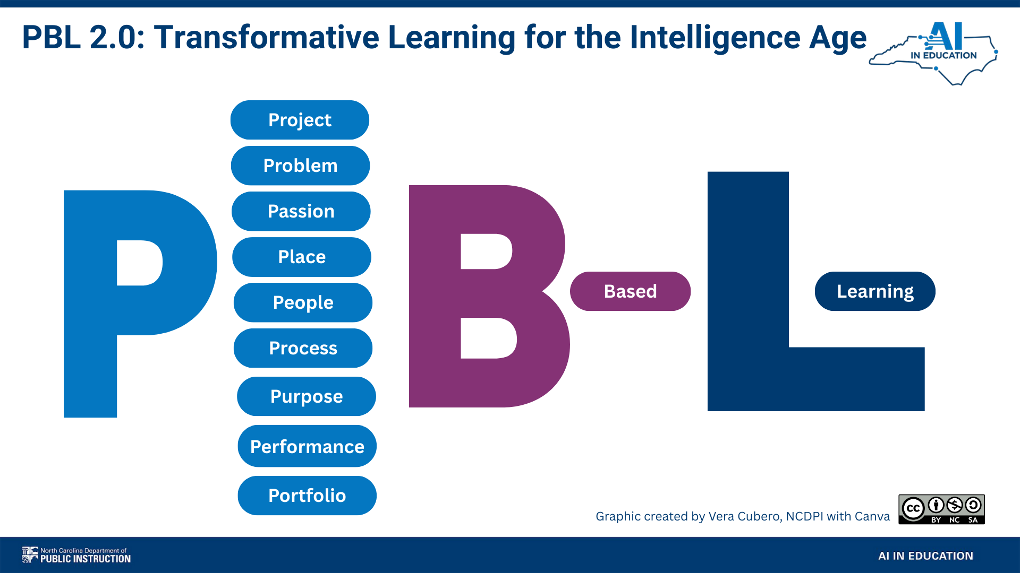

The 9 P's are the design principles that operationalize the 4 levers above.
Each P is a deliberate choice; a way to embed process, agency, authenticity, and reflection into any Micro PBL 2.0 unit:
DESIGNING THE INQUIRY | CONTEXT & CONNECTION | GROWTH & EVIDENCE
1. Project  Collaborative, standards-anchored projects that build durable skills.  2. Problem  Apply curriculum to real-world scenarios, issues, and problems students actually care about.  3. Passion  Pique student interest by letting learners connect personal passions as entry points into content. | 4. Place  Connect learning to a local context — community, environment, or school — that gives work real stakes.  5. People  Build empathy by understanding how the work affects others beyond the walls of the classroom.  6. Purpose  Every project must answer: why does this matter?  Authentic purpose is the core pillar of transformative PBL. | 7. Process  Honor the whole learning journey — not just the final product. Document thinking, learning, human judgment, and agency in motion.  8. Performance  Add value through public presentations, displays, or oral defenses for a real audience.  9. Portfolio  Capture metacognitive reflections throughout.  The focus: learning how to learn — the skill AI cannot replace.

THE DRIVING QUESTION: The Heart of the Lever
In PBL 2.0, the traditional driving question is replaced by a purposeful challenge. It is a complex, open-ended problem with multiple solutions and clear trade-offs that cannot be answered by a single AI prompt. Its primary goal is to force discernment, flexibility, and deep human engagement rather than just the recall of information.
Traditional Assignment  "Write a report on ecosystems."  Limited agency. No real audience. AI can complete this for students.  Googleable; can be answered with a Google search or AI prompt | Driving Question  "How can we redesign our school courtyard to support local biodiversity and student wellbeing?"  Real problem. Real audience. AI is a collaborator, not a replacement  Can not be answered with a Google search or an AI prompt.

MAKING LEARNING VISIBLE

Portfolios, Metacognition & AI as Partner
A defining feature of Micro PBL 2.0 is the Portfolio — not as a final collection of polished products, but as a living record of the learning journey including the messy, beautiful middle where productive struggle happens and metacognitive reflection. Paired with structured reflection, portfolios develop the metacognitive habits that research identifies as among the highest-impact learning strategies.

RESEARCH INSIGHT — JOHN HATTIE, VISIBLE LEARNING
Metacognitive strategies have an effect size of d = 0.69 — well above the average threshold for meaningful impact. Teaching students to monitor, evaluate, and adjust their own learning is one of the most powerful investments educators can make.

THE PORTFOLIO: A Window Into Thinking
In Micro PBL 2.0, portfolios capture three dimensions of learning, not just the product- but the process.
PHASE | WHAT STUDENTS DOCUMENT | PURPOSE
BEFORE the project | Prior knowledge, initial questions, goals, predictions. | Activates schema; creates a baseline to measure growth.
DURING the project | Process notes, drafts, AI interaction logs, peer feedback, pivots and decisions. | Builds metacognitive awareness; shows thinking in motion.
AFTER the project | Final product, reflection on growth, connections to durable skills, next questions. | Demonstrates transfer; celebrates the full learning arc.
LEARNING IS A JOURNEY, NOT A DESTINATION
Portfolios shift the classroom narrative from 'What did you produce?' to 'How did you grow?'
This reframing is especially critical in an AI-enabled world where AI can produce polished products instantly. The irreplaceable human contribution is the thinking, questioning, failing, and iterating behind the product.
Students who document their AI interactions; the prompts they tried, the outputs they rejected, the decisions they made - develop the critical evaluation skills that define AI fluency.

KEY PRINCIPLE
AI amplifies capacity, but it cannot replace curiosity, empathy, or the will to solve real problems.
Our job is to develop the human skills that make AI powerful and keep humans essential.

Transitioning from Group Work to Learning Teams

Traditional collaborative assignments often lead to a familiar and frustrating scenario: one student does all the work while the others coast. This dynamic is rarely a failure of the students themselves, but rather a flaw in the design of the assignment. To foster genuine collaboration and deeper learning, educators must understand the critical structural differences between traditional "group work" and highly effective "learning teams."

 | Traditional Group Work | Learning Teams
Summary | The pitfalls of traditional group work: Group work typically involves placing students together, asking them to divide tasks, and hoping things work out. | The architecture of learning teams:  Learning teams, by contrast, are designed using research-backed principles that intentionally engineer collaboration, ensuring that collective success requires individual mastery.
Core Idea | The primary focus is simply dividing tasks to get a job done. | Teams are built around a genuine commitment to each person's success.
Structure | Traditional groups lack systems for individual accountability. Because tasks are arbitrarily divided and individual contributions aren't measured separately, predictable patterns of "social loafing" emerge, allowing free-riders to coast on the efforts of others. | Learning teams rely on positive interdependence and individual accountability. Instead of just dividing a large task, educators assign each student a specialized, objective-focused "learning mission" or micro-project. Because each student becomes an expert in a distinct area, the overall task physically cannot be completed without every team member's unique contribution
Assessment | Typically, all students receive the exact same grade regardless of their individual effort or understanding. The focus is entirely on the final product rather than the learning process. | Teams utilize a "dual assessment" approach (individual and team; process and product). Educators evaluate both the individual student's mastery of their specific learning mission (process) and the quality of the team's final integrated proposal (product). The guiding rule is that students "learn together but perform individually"
Outcomes | The results are uneven and frustrating, often building resentment among hard workers and reinforcing negative ideas about collaboration. | Well-designed learning teams lead to superior performance and durable skill development. Because the incentive to coast disappears, teams achieve "knowledge convergence"—a shared understanding that far exceeds what any individual student could produce working alone.

The difference between a group and a team is not just semantic; it is structural. By shifting away from parallel individual work that simply gets assembled at the end, and moving toward specialized learning missions that require constant integration, educators can eliminate the free-rider problem and transform group projects into powerful collaborative learning experiences.

Targeted Skill Development Workshops
A key component of the Micro PBL 2.0 philosophy is the inclusion of targeted skill development workshops. These 15-20 minute small group workshops occur concurrently while learning teams are engaged in creating their deliverables. These workshops focus on the micro skills for the focus standard as well as including age-appropriate AI literacy lessons. There should be one workshop per day of the project, with each team cycling through each workshop. The workshop should be narrowly focused on one learning objective related to the standard or AI literacy objective with a brief instruction, teacher demonstration, student activity, and micro formative assessment/exit ticket.
The PBL 2.0 apps below will co-create these with the teacher based on the standard provided.

Example:
Standard: NC SS Standard 8.G.1.1
Explain how human and environmental interaction has affected the development of North Carolina and the United States.

Overall Project Deliverable:
Students collaboratively design a sustainable North Carolina transportation corridor that balances environmental, economic, cultural, and engineering priorities.
Learning Team Roles:
- Environmental Scientist
  - Role: Assess ecosystems along proposed routes; identify risks to rivers, forests, and wildlife; recommend mitigation strategies.
  - Deliverable: Environmental Impact Report with a map of protected zones.
- Economic Strategist
  - Role: Analyze how new transportation affects jobs, tourism, and trade; weigh economic benefits vs. environmental costs
  - Deliverable: Cost-benefit analysis report with visuals
- Infrastructure Engineer
  - Role: Plan the physical design (routes, materials, elevation) and transportation type (road, rail, bike).
  - Deliverable: Blueprint of the route with annotations justifying design choices.
- Cultural Preservation Specialist
  - Role: Research towns and historic landmarks along the corridor to ensure preservation of NC's cultural identity.
  - Deliverable:Cultural heritage map & short proposal to preserve cultural heritage

Try PBL 2.0 Creator Apps
Design your first Micro PBL 2.0 unit in minutes — not hours.
NC DPI has developed two AI-powered Creator Apps that guide educators through the design of NC standards-aligned Micro PBL 2.0 units. Start with a standard, provide context, and co-create a mission-based project — complete with a driving question, authentic product, and Portrait of a Graduate connections.

🔷 GEMINI GEM  PBL 2.0 Creator — powered by Google Gemini  • Accessible from any Google account  • Conversational co-design experience  • Generates full project frameworks  • Ideal for Google Workspace schools  Access: go.ncdpi.gov/PBL-2.0-Gem | 🟢 PLAYLAB APP  NC PBL 2.0 Creator — powered by Playlab AI  • No login required — open access  • Step-by-step guided prompts  • Educator-friendly interface  • Ideal for quick starts or new AI users  Access: go.ncdpi.gov/NCPBL2.0-Creator-Playlab

HOW TO GET STARTED: 5 Steps
- Choose a standard — pick one you're already teaching this month.
2. Open a Creator App — use either the Gemini Gem or Playlab App above.
3. Co-create your project — provide grade level, content, and context; iterate with the AI to fully customize the project to fit your and your student’s needs.
4. Save and adapt — copy your project; refine it to fit your students.
5. Share your work — post to the NC community padlet so others can learn from you.

KEY TAKEAWAYS
Process Over Products  Shift the focus to the learning journey. The messy, iterative process is where real growth — and real AI-proof skill — happens. | Increased Student Agency  Give students meaningful choice in how, what, and why they learn. Ownership is the engine of intrinsic motivation. | Authentic Learning (PBL)  Connect content to real people, places, and problems. When stakes are real, effort and quality follow. | Portfolios + Metacognition  Ongoing documentation of thinking and growth builds the self-awareness that no AI can replicate — learning how to learn.

YOUR CHALLENGE
Choose ONE standard. → Open ONE Creator App. → Design ONE small mission. → Then share it.
The shift starts with a single lever — and that lever starts with you.

ALL SESSION RESOURCES
Session Slides & Resources | go.ncdpi.gov/SmallLevers
Gemini PBL 2.0 Creator (faster) | go.ncdpi.gov/PBL-2.0-Gem
Playlab PBL 2.0 Creator (more thorough) | go.ncdpi.gov/NCPBL2.0-Creator-Playlab
Share Your Project (Padlet) | padlet.com/ncdpi/small_levers
Public PBL NotebookLM Notebook | https://notebooklm.google.com/notebook/8b54abcb-6baf-4b59-a3e2-2f786876f156

References

References

AI for Education. AI Adoption Roadmap for Education Institutions. 29 Nov. 2024, www.aiforeducation.io/ai-resources/ai-adoption-roadmap-for-education-institutions. Accessed 7 May 2025.

AI for Education. Guide to Developing an AI Policy for Your School. 29 Nov. 2024, www.aiforeducation.io/ai-resources/ai-policy-guide-school. Accessed 7 May 2025.

AI for Education & Vera Cubero. How to Use AI Responsibly EVERY Time. 25 Nov. 2024, www.aiforeducation.io/ai-resources/how-to-use-ai-responsibly-every-time. Accessed 2 May 2025.

Altman, Sam. “Planning for AGI and Beyond.” OpenAI Blog, 2023, https://openai.com/blog/planning-for-agi-and-beyond. Accessed 2 May 2025.

Aristek Systems. “How AI Helps to Create an Accessible Learning Environment.” LinkedIn, 16 Apr. 2025, www.linkedin.com/pulse/how-ai-helps-create-accessible-learning-environment-aristeksystems-aiife. Accessed 7 May 2025.

Barton, Josh. Technical Assistance: Acceptable Use of AI for Special Education Teachers and Related Service Providers. North Carolina Department of Public Instruction, Office of Exceptional Children, Apr. 2025. Accessed 7 May 2025.

Bubeck, Sébastien, et al. “Sparks of Artificial General Intelligence: Early Experiments with GPT-4.” arXiv, 2023, https://arxiv.org/pdf/2303.12712.

Clark, Holly. “Why AI Detectors Are Problematic and What To Do Instead.” Holly Clark, 22 Sept. 2023, www.hollyclark.org/2023/09/22/why-ai-detectors-are-problematic-and-what-to-do-instead/. Accessed 2 May 2025.

Cleary, Dan. “How Polite Should We Be When Prompting LLMs?” Medium, 11 Mar. 2024, medium.com/@dan_43009/how-polite-should-we-be-when-prompting-llms-0c0dd9c9e06c . Accessed 7 May 2025.

Common Sense Media. “Talk, Trust, and Trade‑Offs: How and Why Teens Use AI Companions.” Common Sense Media, 17 July 2025, www.commonsensemedia.org/research/talk-trust-and-trade-offs-how-and-why-teens-use-ai-companions. Accessed 24 July 2025.

Cubero, Vera. “Responsible Use EVERY Time.” ChatGPT, OpenAI, n.d., https://chatgpt.com/g/g-C37F5sFI9-responsible-use-every-time. Accessed 2 May 2025.

European Commission and Organisation for Economic Co‑operation and Development. “Empowering Learners for the Age of AI: An AI Literacy Framework for Primary and Secondary Education.” AILit Framework, Organisation for Economic Co‑operation and Development, 2025, https://ailiteracyframework.org/. Accessed 24 July 2025.

Federal Trade Commission. “FTC Finalizes Changes to Children’s Privacy Rule Limiting Companies’ Ability to Monetize Kids’ Data.” Federal Trade Commission, 16 Jan. 2025, www.ftc.gov/news-events/news/press-releases/2025/01/ftc-finalizes-changes-childrens-privacy-rule-limiting-companies-ability-monetize-kids-data. Accessed 2 May 2025.

Future of Privacy Forum. Deepfakes in School: Risks and Readiness. Mar. 2025, https://fpf.org/wp-content/uploads/2025/03/FPF-Deep-Fake_illo03-FPF-AI.pdf.

Leon Furze. “Updating the AI Assessment Scale.” LeonFurze.com, 28 Aug. 2024, https://leonfurze.com/2024/08/28/updating-the-ai-assessment-scale/. Accessed 7 May 2025.

Markham, Thom. “The Unfolding Vision of AI and Project Based Learning.” The Learning Counsel, 24 Mar. 2025, https://thelearningcounsel.com/articles/the-unfolding-vision-of-ai-and-project-based-learning/. Accessed 7 May 2025.

North Carolina General Assembly. House Bill 591 / Session Law 2024-37, “Modernize Sex Crimes.” 2023–2024 Session, enacted 8 July 2024, https://www.ncleg.gov/Sessions/2023/Bills/House/PDF/H591v5.pdf. Accessed 2 May 2025.

OpenAI. “Introducing OpenAI o1.” OpenAI, 5 Dec. 2024, https://openai.com/o1/. Accessed 7 May 2025.

Organisation for Economic Co-operation and Development. Empowering Learners for the Age of AI: An AI Literacy Framework for Primary and Secondary Education (Review Draft). AILit Framework, OECD, 2025, https://ailiteracyframework.org/. Accessed 22 May 2025.

PromptHub. “How Polite Should We Be When Prompting LLMs?” PromptHub Blog, 27 Mar. 2025.

Rasita, Vinay, et al. “Emotional Prompting Amplifies Disinformation Generation in AI Large Language Models.” Frontiers in Artificial Intelligence, vol. 8, 7 Apr. 2025, doi:10.3389/frai.2025.1543603. Accessed 7 May 2025

Sheffield, Toria. “OpenAI CEO Claims Saying ‘Please’ and ‘Thank You’ to ChatGPT Costs ‘Tens of Millions of Dollars’ — Here’s Why.” People, 26 Apr. 2025, https://people.com/open-ai-ceo-claims-saying-please-thank-you-to-chatgpt-costs-millions-of-dollars-in-electricity-bills-11721523. Accessed 7 May 2025.

TeachAI Toolkit. Code.org, 2023, https://www.teachai.org/toolkit.

“Top 10 GenAI Use Cases: 2024 vs. 2025.” Harvard Business Review, Filtered.com, 2025. https://filtered.com/blog/top-10-genai-use-cases-2024-vs-2025. Accessed 8 May 2025.

Tracking AI. “Mensa Norway IQ Scores (Average of Last 7 Tests).” TrackingAI.org – A MaximumTruth.org Project, 17 Apr. 2025, www.trackingai.org. Accessed 26 Apr. 2025.

U.S. Department of Education. Artificial Intelligence and the Future of Teaching and Learning: Insights and Recommendations. May 2023, https://tech.ed.gov/ai-future-of-teaching-and-learning/. Accessed 7 May 2025.

UNESCO. AI and Education: Guidance for Policy-Makers. 2024, https://unesdoc.unesco.org/ark:/48223/pf0000385348.

United States, Congress, Senate. S. 146, Tools to Address Known Exploitation by Immobilizing Technological Deepfakes on Websites and Networks Act (TAKE IT DOWN Act), 119th Cong., 1st sess., introduced 16 Jan. 2025. Congress.gov.

U.S. Patent and Trademark Office. Guidance on Use of Artificial Intelligence-Based Tools in Practice Before the United States Patent and Trademark Office. Federal Register, vol. 89, no. 71, 11 Apr. 2024, pp. 25609–25617, https://www.federalregister.gov/documents/2024/04/11/2024-07629/guidance-on-use-of-artificial-intelligence-based-tools-in-practice-before-the-united-states-patent. Accessed 2 May 2025.

Wemyss, Matthew. “AI Insights Focus: What’s OpenClaw and why should I care?” LinkedIn, 2 Feb. 2026, https://www.linkedin.com/pulse/ai-insights-focus-whats-openclaw-why-should-i-care-matthew-wemyss-cr7of/. Accessed 2 Feb. 2026.

World Economic Forum. Future of Jobs Report 2025. Insight Report, 2025, pp. 12–18

World Economic Forum. Future of Jobs Report 2025. Insight Report, World Economic Forum, 2025, pp. 12–18.
Bubeck, Sébastien, et al. "Sparks of Artificial General Intelligence: Early Experiments with GPT-4." arXiv,https://arxiv.org/pdf/2303.12712 2023.
Organisation for Economic Co-operation and Development. Empowering Learners for the Age of AI: An AI Literacy Framework for Primary and Secondary Education (Review Draft). OECD, May 2025, https://ailiteracyframework.org/.
UNESCO. AI and Education: Guidance for Policy-Makers. 2024. https://unesdoc.unesco.org/ark:/48223/pf0000385348.
TeachAI Toolkit. Code.org, 2023, https://www.teachai.org/toolkit.
OECD, Empowering Learners for the Age of AI: An AI Literacy Framework for Primary and Secondary Education (Review Draft), OECD, May 2025, AILit Framework, https://ailiteracyframework.org/wp-content/uploads/2025/05/AILitFramework_ReviewDraft.pdf.
North Carolina Department of Public Instruction. Portrait of a Graduate. 2021,https://www.dpi.nc.gov/districts-schools/operation-polaris/portrait-graduate
Artificial Intelligence and the Future of Teaching and Learning: Insights and Recommendations. U.S. Department of Education, May 2023, https://tech.ed.gov/ai-future-of-teaching-and-learning/.
AI Adoption Roadmap for Education Institutions.” AI for Education, 29 Nov. 2024, https://www.aiforeducation.io/ai-resources/ai-adoption-roadmap-for-education-institutions. Accessed 7 May 2025.
“Guide to Developing an AI Policy for Your School.” AI for Education, 29 Nov. 2024, https://www.aiforeducation.io/ai-resources/ai-policy-guide-school. Accessed 7 May 2025.
“Introducing OpenAI o1.” OpenAI, 5 Dec. 2024, https://openai.com/o1/. Accessed 7 May 2025.
“Social AI Companions.” Common Sense Media, https://www.commonsensemedia.org/ai-ratings/social-ai-companions. Accessed 7 May 2025.
“Top 10 GenAI Use Cases: 2024 vs. 2025.” Harvard Business Review, Filtered.com, 2025. Accessed 8 May 2025.
“Talk, Trust, and Trade-Offs: How and Why Teens Use AI Companions.” Common Sense Media, https://www.commonsensemedia.org/research/talk-trust-and-trade-offs-how-and-why-teens-use-ai-companions . Accessed 24 July 2025.
Mattel, Inc. “Mattel and OpenAI Announce Strategic Collaboration.” Mattel Newsroom, 12 June 2025, corporate.mattel.com/news/mattel-and-openai-announce-strategic-collaboration. Accessed 25 Feb. 2026.
Curio Interactive Inc. “Privacy Policy.” Curio, last modified 24 Jan. 2024, heycurio.com/privacy. Accessed 25 Feb. 2026.
“Advancing Artificial Intelligence Education for American Youth.” The White House, 23 Apr. 2025, https://www.whitehouse.gov/presidential-actions/2025/04/advancing-artificial-intelligence-education-for-american-youth/. Accessed 7 May 2025.
Organisation for Economic Co-operation and Development. Empowering Learners for the Age of AI: An AI Literacy Framework for Primary and Secondary Education (Review Draft). OECD, May 2025, https://ailiteracyframework.org/.
“AI Adoption Roadmap for Education Institutions.” AI for Education, 29 Nov. 2024, https://www.aiforeducation.io/ai-resources/ai-adoption-roadmap-for-education-institutions. Accessed 7 May 2025.
Organisation for Economic Co-operation and Development. Empowering Learners for the Age of AI: An AI Literacy Framework for Primary and Secondary Education (Review Draft). OECD, May 2025, https://ailiteracyframework.org/.
Cleary, Dan. “How Polite Should We Be When Prompting LLMs?” Medium, 11 Mar. 2024, https://medium.com/@dan_43009/how-polite-should-we-be-when-prompting-llms-0c0dd9c9e06c. Accessed 7 May 2025.
Toria Sheffield, “OpenAI CEO Claims Saying ‘Please’ and ‘Thank You’ to ChatGPT Costs ‘Tens of Millions of Dollars’ — Here’s Why,” People, 26 Apr. 2025, https://people.com/open-ai-ceo-claims-saying-please-thank-you-to-chatgpt-costs-millions-of-dollars-in-electricity-bills-11721523. Accessed 7 May 2025.
Vinay Rasita et al., “Emotional Prompting Amplifies Disinformation Generation in AI Large Language Models,” Frontiers in Artificial Intelligence, vol. 8, 7 Apr. 2025, doi:10.3389/frai.2025.1543603. Accessed 7 May 2025.
AI for Education. “How to Use AI Responsibly EVERY Time.” AI for Education & Vera Cubero, 25 Nov. 2024, www.aiforeducation.io/ai-resources/how-to-use-ai-responsibly-every-time. Accessed 2 May 2025.
U.S. Patent and Trademark Office. Guidance on Use of Artificial Intelligence-Based Tools in Practice Before the United States Patent and Trademark Office. Federal Register, vol. 89, no. 71, 11 Apr. 2024, pp. 25609-25617. United States Government Publishing Office, https://www.federalregister.gov/documents/2024/04/11/2024-07629/guidance-on-use-of-artificial-intelligence-based-tools-in-practice-before-the-united-states-patent. Accessed 2 May 2025.
Leon Furze. “Updating the AI Assessment Scale.” LeonFurze.com, 28 Aug. 2024, https://leonfurze.com/2024/08/28/updating-the-ai-assessment-scale/.
Clark, Holly. “Why AI Detectors Are Problematic and What To Do Instead.” Holly Clark, 22 Sept. 2023, www.hollyclark.org/2023/09/22/why-ai-detectors-are-problematic-and-what-to-do-instead/. Accessed 2 May 2025.
Matthew Wemyss, “AI Insights Focus: What’s OpenClaw and why should I care?,” LinkedIn, 2 Feb. 2026, https://www.linkedin.com/pulse/ai-insights-focus-whats-openclaw-why-should-i-care-matthew-wemyss-cr7of/ . Accessed 2 Feb. 2026.
North Carolina General Assembly. House Bill 591 / Session Law 2024-37, “Modernize Sex Crimes.” 2023–2024 Session, enacted 8 July 2024. North Carolina General Assembly, https://www.ncleg.gov/Sessions/2023/Bills/House/PDF/H591v5.pdf. Accessed 2 May 2025.
United States, Congress, Senate. S. 146, Tools to Address Known Exploitation by Immobilizing Technological Deepfakes on Websites and Networks Act (TAKE IT DOWN Act), 119th Cong., 1st sess., introduced 16 Jan. 2025. Congress.gov.
Future of Privacy Forum. Deepfakes in School: Risks and Readiness. Future of Privacy Forum, Mar. 2025, https://fpf.org/wp-content/uploads/2025/03/FPF-Deep-Fake_illo03-FPF-AI.pdf.
Federal Trade Commission. “FTC Finalizes Changes to Children’s Privacy Rule Limiting Companies’ Ability to Monetize Kids’ Data.” Federal Trade Commission, 16 Jan. 2025, www.ftc.gov/news-events/news/press-releases/2025/01/ftc-finalizes-changes-childrens-privacy-rule-limiting-companies-ability-monetize-kids-data. Accessed 2 May 2025.
North Carolina Department of Public Instruction. “Third Party Data Integration.” NC DPI, n.d., https://www.dpi.nc.gov/about-dpi/technology-services/third-party-data-integration. Accessed 2 May 2025.
“Top 5 Questions for GenAI EdTech Providers.” AI for Education, 23 Oct. 2024, www.aiforeducation.io/ai-resources/questions-genai-edtech. Accessed 26 Apr. 2025.
“GenAI Rubric for NC School Districts.” Google Docs, n.d., https://docs.google.com/document/d/1CEn_AzVpoTJLg3gQmJFoIkui3Hsfv9gHXETELjslBVY/edit. Accessed 2 May 2025.
European Commission and Organisation for Economic Co-operation and Development. Empowering Learners for the Age of AI: An AI Literacy Framework for Primary and Secondary Education. OECD, 2025, https://ailiteracyframework.org. Accessed 17 June 2025.
“Prompt Library.” AI for Education, https://www.aiforeducation.io/prompt-library. Accessed 7 May 2025.

